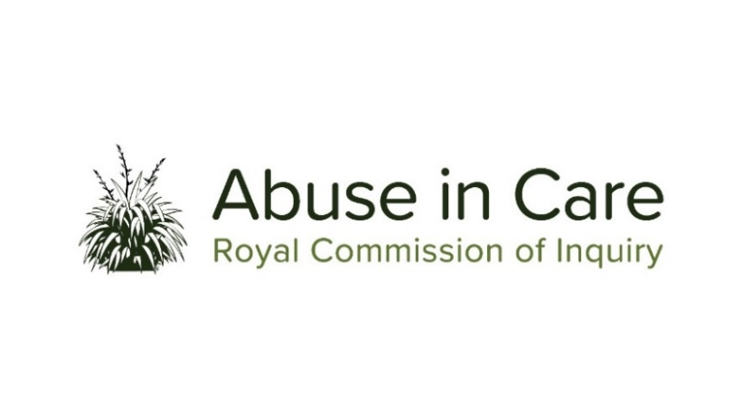
INVESTIGATION INTO ABUSE IN
STATE YOUTH JUSTICE CARE

SCOPE OF INVESTIGATION

- This investigation will examine abuse in State-based youth justice care (State youth justice care) in New Zealand, being:

  - the abuse of children, young people and vulnerable adults in (or while being transferred to, between, or out of) the following State youth justice care settings:

    - Youth justice residences (including institutions and third-party providers that also provided care and protection and/or training facilities);
    - Borstals;
    - Youth prisons (also known as ‘youth institutions’);
    - Detention centres;
    - Corrective training institutions; and
    - Other youth justice placements; and

(State youth justice care settings)

  - the abuse of children and young people in (or while being transferred to, between, or out of):

    - Adult prisons, where the individual was also in State care at the time; and
    - Transitional and law enforcement settings, including court cells, police cells, police jails, other police custody, and remand facilities.

- Abuse is defined in the Inquiry’s Terms of Reference as meaning physical, sexual, emotional or psychological abuse, and neglect. It includes inadequate or improper treatment that resulted in serious mental or physical harm to a person in care. Neglect is not defined in the Terms of Reference, but the Inquiry considers neglect may include physical, emotional and psychological, medical, educational, spiritual and cultural neglect.
- The main period of investigation is 1950 to 1999, however the Inquiry has discretion to consider issues and experiences prior to 1950 and may also consider issues and experiences after 1999 for the purposes of making recommendations on redress or on future changes to ensure that factors that allowed abuse to occur in care during the relevant period do not persist.
- The Terms of Reference define children and young people as being under the age of 18 years. During the period of investigation young adults aged between 18-23 years were also detained in State youth justice care settings. The Inquiry considers that these individuals were vulnerable adults as defined in clause 17.2 of the Terms of Reference and will also examine their experiences of abuse in care.
- During the course of this investigation the Inquiry will select institutions, issues or themes as case studies of abuse in State youth justice care and may conduct research and examine relevant matters in public hearings, roundtables, wānanga, hui and fono.
- The Inquiry will consider the voices and experiences of victims and survivors of abuse in State youth justice care. It will investigate and make findings on what happened and why including by examining:
  - The circumstances of being taken into or placed into State youth justice care, and the appropriateness of those placements;
  - The nature and extent of abuse in State youth justice care;
  - The impact, including any differential impact, of abuse of victims and survivors, and on their families, whānau, hapū, iwi and communities. This will include consideration of:
    - Tikanga Māori when considering the impacts of abuse on Māori victims and survivors and their whānau, hapū and iwi;
    - Pacific cultural norms and values when considering the impact of abuse on victims and survivors among Pacific people;
    - Particular impacts related to disability and mental health status, including additional barriers to understanding and recognising abuse, disclosing abuse, accessing specialist wellbeing supports to respond to trauma, and receiving redress.
  - Whether individuals experienced abuse because of nationality, race, ethnicity, religious belief, age, gender, gender identity, sexual orientation, or physical or intellectual disability, neurodiversity or mental health status;
  - Any structural, systemic, practical or other factors that caused or contributed to abuse in State youth justice care;
  - The adequacy of any actions by the State to prevent and respond to abuse in State youth justice care, including any lessons learned and changes made;
  - The applicable principles and obligations of Te Tiriti o Waitangi/the Treaty of Waitangi;
  - The State’s obligations under domestic and international law, including human rights law;
  - The adequacy of the State’s redress and rehabilitation processes for victims and survivors of abuse in State youth justice care.
- The Inquiry will also assess and make recommendations on:
  - any changes required to the redress, rehabilitation and compensation processes for victims and survivors of abuse in State youth justice care;
  - any other steps the State should take to address the harm caused by abuse in State youth justice care.

- The Inquiry may make recommendations for changes to be made in the future to ensure that the factors that allowed abuse to occur during the relevant period in State youth justice care institutions do not persist.

- Where relevant, the Inquiry may make findings of fault or that relevant standards have been breached, or both. The Inquiry does not have the power to determine the civil, criminal or disciplinary liability of any person but may make recommendations that further steps be taken to determine liability.

Including those private institutions provided for in the Child Welfare Act 1925, the Children and Young Persons Act 1974, and s 396 Oranga Tamariki Act 1989.
With the exception of foster care and family homes placements. Abuse that occurred in these settings will be examined by the Inquiry in its Foster Care investigation.

