Abuse In Care Data Request - 20/09/2023

For people who identified as Pacific:
- What proportion of those who experienced state-based care reported different types of abuse (physical/sexual/psych, etc.)
- What proportion of those who experienced faith-based care reported different types of abuse (physical/sexual/psych, etc.)
- What proportion of those who experienced disability or mental health care reported different types of abuse (physical/sexual/psych, etc.)
Ethnicity | Setting Type | Abuse Type | Number of Survivors | Percentage of Survivors
Pacific | Social Welfare and Youth Justice | Neglect | 22 | 29%
 |  | Emotional | 33 | 44%
 |  | Physical | 47 | 63%
 |  | Sexual | 39 | 52%
 |  | Child Labour | 5 | 7%
 |  | Medical | 3 | 4%
 |  | Non-Contact Sexual | 0 | 0%
 |  | Solitary | 0 | 0%
 |  | Unknown Type | 15 | 20%
 |  | No Abuse Reported | 17 | 23%
 |  | Total Survivors in Care | 75
 | Faith | Neglect | 4 | 12%
 |  | Emotional | 4 | 12%
 |  | Physical | 15 | 45%
 |  | Sexual | 11 | 33%
 |  | Child Labour | 0 | 0%
 |  | Medical | 0 | 0%
 |  | Non-Contact Sexual | 0 | 0%
 |  | Solitary | 0 | 0%
 |  | Unknown Type | 4 | 12%
 |  | No Abuse Reported | 12 | 36%
 |  | Total Survivors in Care | 33
 | Disability and Mental Distress | Neglect | 5 | 36%
 |  | Emotional | 3 | 21%
 |  | Physical | 4 | 29%
 |  | Sexual | 3 | 21%
 |  | Child Labour | 0 | 0%
 |  | Medical | 0 | 0%
 |  | Non-Contact Sexual | 1 | 7%
 |  | Solitary | 0 | 0%
 |  | Unknown Type | 0 | 0%
 |  | No Abuse Reported | 5 | 36%
 |  | Total Survivors in Care | 14
 | Other | Neglect | 3 | 25%
 |  | Emotional | 4 | 33%
 |  | Physical | 3 | 25%
 |  | Sexual | 3 | 25%
 |  | Child Labour | 1 | 8%
 |  | Medical | 0 | 0%
 |  | Non-Contact Sexual | 0 | 0%
 |  | Solitary | 0 | 0%
 |  | Unknown Type | 0 | 0%
 |  | No Abuse Reported | 7 | 58%
 |  | Total Survivors in Care | 12
 | Education | Neglect | 0 | 0%
 |  | Emotional | 0 | 0%
 |  | Physical | 1 | 100%
 |  | Sexual | 1 | 100%
 |  | Child Labour | 0 | 0%
 |  | Medical | 0 | 0%
 |  | Non-Contact Sexual | 0 | 0%
 |  | Solitary | 0 | 0%
 |  | Unknown Type | 0 | 0%
 |  | No Abuse Reported | 0 | 0%
 |  | Total Survivors in Care | 1

For people who identified as Māori:
- What proportion of those who experienced state-based care reported different types of abuse (physical/sexual/psych, etc.) in state-based care settings
- What proportion of those who experienced faith-based care reported different types of abuse (physical/sexual/psych, etc.) in faith-based care settings
- What proportion of those who experienced disability or mental health care reported different types of abuse (physical/sexual/psych, etc.) in disability or mental health care settings

Ethnicity | Setting Type | Abuse Type | Number of Survivors | Percentage of Survivors
Māori | Social Welfare and Youth Justice | Neglect | 224 | 30%
 |  | Emotional | 371 | 49%
 |  | Physical | 456 | 60%
 |  | Sexual | 403 | 53%
 |  | Child Labour | 56 | 7%
 |  | Medical | 19 | 3%
 |  | Non-Contact Sexual | 21 | 3%
 |  | Solitary | 2 | 0.3%
 |  | Unknown Abuse | 150 | 20%
 |  | No Abuse Reported | 125 | 16%
 |  | Total Survivors in Care | 759
 | Faith | Neglect | 22 | 10%
 |  | Emotional | 78 | 34%
 |  | Physical | 91 | 39%
 |  | Sexual | 91 | 39%
 |  | Child Labour | 9 | 4%
 |  | Medical | 2 | 1%
 |  | Non-Contact Sexual | 9 | 4%
 |  | Solitary | 0 | 0%
 |  | Unknown Abuse | 35 | 15%
 |  | No Abuse Reported | 63 | 27%
 |  | Total Survivors in Care | 231
 | Disability and Mental Distress | Neglect | 39 | 23%
 |  | Emotional | 52 | 31%
 |  | Physical | 78 | 46%
 |  | Sexual | 56 | 33%
 |  | Child Labour | 0 | 0%
 |  | Medical | 17 | 10%
 |  | Non-Contact Sexual | 4 | 2%
 |  | Solitary | 1 | 1%
 |  | Unknown Abuse | 26 | 15%
 |  | No Abuse Reported | 41 | 24%
 |  | Total Survivors in Care | 168
 | Other | Neglect | 10 | 8%
 |  | Emotional | 24 | 19%
 |  | Physical | 20 | 16%
 |  | Sexual | 19 | 15%
 |  | Child Labour | 1 | 1%
 |  | Medical | 0 | 0%
 |  | Non-Contact Sexual | 3 | 2%
 |  | Solitary | 0 | 0%
 |  | Unknown Abuse | 6 | 5%
 |  | No Abuse Reported | 84 | 66%
 |  | Total Survivors in Care | 127
 | Education | Neglect | 4 | 7%
 |  | Emotional | 11 | 18%
 |  | Physical | 14 | 23%
 |  | Sexual | 17 | 28%
 |  | Child Labour | 0 | 0%
 |  | Medical | 0 | 0%
 |  | Non-Contact Sexual | 0 | 0%
 |  | Solitary | 0 | 0%
 |  | Unknown Abuse | 2 | 3%
 |  | No Abuse Reported | 29 | 48%
 |  | Total Survivors in Care | 61

For people who identified as Pakeha:
- What proportion of those who experienced state-based care reported different types of abuse (physical/sexual/psych, etc.)
- What proportion of those who experienced faith-based care reported different types of abuse (physical/sexual/psych, etc.)
- What proportion of those who experienced disability or mental health care reported different types of abuse (physical/sexual/psych, etc.)

Ethnicity | Setting Type | Abuse Type | Number of Survivors | Percentage of Survivors
Pakeha | Social Welfare and Youth Justice | Neglect | 225 | 30%
 |  | Emotional | 340 | 46%
 |  | Physical | 401 | 54%
 |  | Sexual | 368 | 50%
 |  | Child Labour | 46 | 6%
 |  | Medical | 25 | 3%
 |  | Non-Contact Sexual | 36 | 5%
 |  | Solitary | 3 | 0.4%
 |  | Unknown Abuse | 162 | 22%
 |  | No Abuse Reported | 118 | 16%
 |  | Total Survivors in Care | 740
 | Faith | Neglect | 81 | 13%
 |  | Emotional | 270 | 43%
 |  | Physical | 239 | 38%
 |  | Sexual | 302 | 49%
 |  | Child Labour | 20 | 3%
 |  | Medical | 6 | 1%
 |  | Non-Contact Sexual | 38 | 6%
 |  | Solitary | 2 | 0.3%
 |  | Unknown Abuse | 81 | 13%
 |  | No Abuse Reported | 107 | 17%
 |  | Total Survivors in Care | 622
 | Disability and Mental Distress | Neglect | 70 | 23%
 |  | Emotional | 114 | 38%
 |  | Physical | 133 | 44%
 |  | Sexual | 106 | 35%
 |  | Child Labour | 2 | 1%
 |  | Medical | 30 | 10%
 |  | Non-Contact Sexual | 10 | 3%
 |  | Solitary | 2 | 1%
 |  | Unknown Abuse | 46 | 15%
 |  | No Abuse Reported | 58 | 19%
 |  | Total Survivors in Care | 300
 | Other | Neglect | 23 | 11%
 |  | Emotional | 46 | 23%
 |  | Physical | 32 | 16%
 |  | Sexual | 29 | 14%
 |  | Child Labour | 0 | 0%
 |  | Medical | 12 | 6%
 |  | Non-Contact Sexual | 3 | 1%
 |  | Solitary | 0 | 0%
 |  | Unknown Abuse | 18 | 9%
 |  | No Abuse Reported | 119 | 59%
 |  | Total Survivors in Care | 202
 | Education | Neglect | 10 | 10%
 |  | Emotional | 41 | 39%
 |  | Physical | 36 | 34%
 |  | Sexual | 43 | 41%
 |  | Child Labour | 1 | 1%
 |  | Medical | 2 | 2%
 |  | Non-Contact Sexual | 3 | 3%
 |  | Solitary | 0 | 0%
 |  | Unknown Abuse | 8 | 8%
 |  | No Abuse Reported | 28 | 27%
 |  | Total Survivors in Care | 105

For female survivors

What types of abuse were most commonly reported, counting survivors
Gender | Abuse Type | Number of Survivors | Percentage of Survivors
Female | Neglect | 293 | 34%
 | Emotional | 508 | 58%
 | Physical | 457 | 52%
 | Sexual | 498 | 57%
 | Child Labour | 52 | 6%
 | Medical | 57 | 7%
 | Non-Contact Sexual | 51 | 6%
 | Solitary | 4 | 0.5%
 | Unknown Type | 162 | 19%
 | No Abuse Record | 82 | 9%
 | Total Survivors in Care | 871

What proportion reported abuse in State, faith-based or disability mental health settings respectively, counting survivors

Gender | Setting Type | Abuse Type | Number of Survivors | Percentage of Survivors
Female | Social Welfare and Youth Justice | Neglect | 179 | 34%
 |  | Emotional | 264 | 51%
 |  | Physical | 267 | 51%
 |  | Sexual | 286 | 55%
 |  | Child Labour | 33 | 6%
 |  | Medical | 22 | 4%
 |  | Non-Contact Sexual | 23 | 4%
 |  | Solitary | 2 | 0.4%
 |  | Unknown Type | 108 | 21%
 |  | No Abuse Reported | 71 | 14%
 |  | Total Survivors in Care | 522
 | Faith | Neglect | 60 | 19%
 |  | Emotional | 153 | 48%
 |  | Physical | 117 | 37%
 |  | Sexual | 146 | 46%
 |  | Child Labour | 18 | 6%
 |  | Medical | 4 | 1%
 |  | Non-Contact Sexual | 18 | 6%
 |  | Solitary | 1 | 0%
 |  | Unknown Type | 35 | 11%
 |  | No Abuse Reported | 63 | 20%
 |  | Total Survivors in Care | 318
 | Disability and Mental Distress | Neglect | 38 | 25%
 |  | Emotional | 64 | 42%
 |  | Physical | 62 | 41%
 |  | Sexual | 40 | 26%
 |  | Child Labour | 0 | 0%
 |  | Medical | 22 | 14%
 |  | Non-Contact Sexual | 5 | 3%
 |  | Solitary | 1 | 1%
 |  | Unknown Type | 19 | 12%
 |  | No Abuse Reported | 40 | 26%
 |  | Total Survivors in Care | 152
 | Other | Neglect | 23 | 14%
 |  | Emotional | 43 | 27%
 |  | Physical | 22 | 14%
 |  | Sexual | 26 | 16%
 |  | Child Labour | 1 | 1%
 |  | Medical | 9 | 6%
 |  | Non-Contact Sexual | 4 | 2%
 |  | Solitary | 0 | 0%
 |  | Unknown Type | 15 | 9%
 |  | No Abuse Reported | 88 | 55%
 |  | Total Survivors in Care | 161
 | Education | Neglect | 5 | 10%
 |  | Emotional | 17 | 33%
 |  | Physical | 10 | 19%
 |  | Sexual | 16 | 31%
 |  | Child Labour | 0 | 0%
 |  | Medical | 2 | 4%
 |  | Non-Contact Sexual | 1 | 2%
 |  | Solitary | 0 | 0%
 |  | Unknown Type | 6 | 12%
 |  | No Abuse Reported | 21 | 40%
 |  | Total Survivors in Care | 52

For male survivors

What types of abuse were most commonly reported, counting survivors

Gender | Abuse Type | Number of Survivors | Percentage of Survivors
Male | Neglect | 311 | 24%
 | Emotional | 629 | 48%
 | Physical | 786 | 60%
 | Sexual | 741 | 57%
 | Child Labour | 76 | 6%
 | Medical | 58 | 4%
 | Non-Contact Sexual | 61 | 5%
 | Solitary | 8 | 1%
 | Unknown Type | 255 | 20%
 | No Abuse Reported | 145 | 11%
 | Total Survivors in Care | 1303

What proportion reported abuse in State, faith-based or disability mental health settings respectively, counting survivors

Gender | Setting Type | Abuse Type | Number of Survivors | Percentage of Survivors
Male | Social Welfare and Youth Justice | Neglect | 204 | 25%
 |  | Emotional | 354 | 44%
 |  | Physical | 486 | 60%
 |  | Sexual | 394 | 49%
 |  | Child Labour | 58 | 7%
 |  | Medical | 18 | 2%
 |  | Non-Contact Sexual | 26 | 3%
 |  | Solitary | 4 | 0%
 |  | Unknown Type | 172 | 21%
 |  | No Abuse Reported | 144 | 18%
 |  | Total Survivors in Care | 810
 | Faith | Neglect | 41 | 8%
 |  | Emotional | 168 | 34%
 |  | Physical | 185 | 38%
 |  | Sexual | 239 | 49%
 |  | Child Labour | 14 | 3%
 |  | Medical | 4 | 1%
 |  | Non-Contact Sexual | 26 | 5%
 |  | Solitary | 1 | 0.2%
 |  | Unknown Type | 68 | 14%
 |  | No Abuse Reported | 104 | 21%
 |  | Total Survivors in Care | 491
 | Disability and Mental Distress | Neglect | 54 | 19%
 |  | Emotional | 90 | 32%
 |  | Physical | 125 | 45%
 |  | Sexual | 103 | 37%
 |  | Child Labour | 2 | 1%
 |  | Medical | 27 | 10%
 |  | Non-Contact Sexual | 6 | 2%
 |  | Solitary | 2 | 1%
 |  | Unknown Type | 50 | 18%
 |  | No Abuse Reported | 55 | 20%
 |  | Total Survivors in Care | 280
 | Other | Neglect | 11 | 8%
 |  | Emotional | 20 | 14%
 |  | Physical | 26 | 19%
 |  | Sexual | 18 | 13%
 |  | Child Labour | 0 | 0%
 |  | Medical | 5 | 4%
 |  | Non-Contact Sexual | 1 | 1%
 |  | Solitary | 0 | 0%
 |  | Unknown Type | 7 | 5%
 |  | No Abuse Reported | 95 | 68%
 |  | Total Survivors in Care | 139
 | Education | Neglect | 9 | 9%
 |  | Emotional | 33 | 33%
 |  | Physical | 34 | 34%
 |  | Sexual | 38 | 38%
 |  | Child Labour | 1 | 1%
 |  | Medical | 0 | 0%
 |  | Non-Contact Sexual | 3 | 3%
 |  | Solitary | 0 | 0%
 |  | Unknown Type | 6 | 6%
 |  | No Abuse Reported | 28 | 28%
 |  | Total Survivors in Care | 100

For survivors who did not identify as male or female

What types of abuse were most commonly reported

Gender | Abuse Type | Number of Survivors | Percentage of Survivors
Gender diverse, Non Binary, Other, Prefer Not To Say and Unidentified | Neglect | 7 | 44%
 | Emotional | 10 | 62%
 | Physical | 7 | 44%
 | Sexual | 7 | 44%
 | Child Labour | 0 | 0%
 | Medical | 0 | 0%
 | Non-Contact Sexual | 0 | 0%
 | Solitary | 0 | 0%
 | Unknown Type | 1 | 6%
 | No Abuse Reported | 3 | 19%
 | Total Survivors in Care | 16

What proportion reported abuse in State, faith-based or disability mental health settings respectively
Gender | Setting Type | Abuse Type | Number of Survivors | Percentage of Survivors
Non Binary/Unidentified | Social Welfare and Youth Justice | Neglect | 4 | 67%
 |  | Emotional | 4 | 67%
 |  | Physical | 3 | 50%
 |  | Sexual | 3 | 50%
 |  | Child Labour | 0 | 0%
 |  | Medical | 0 | 0%
 |  | Non-Contact Sexual | 0 | 0%
 |  | Solitary | 0 | 0%
 |  | Unknown Type | 0 | 0%
 |  | No Abuse Reported | 1 | 17%
 |  | Total Survivors in Care | 6
 | Faith | Neglect | 2 | 33%
 |  | Emotional | 5 | 83%
 |  | Physical | 4 | 67%
 |  | Sexual | 3 | 50%
 |  | Child Labour | 0 | 0%
 |  | Medical | 0 | 0%
 |  | Non-Contact Sexual | 0 | 0%
 |  | Solitary | 0 | 0%
 |  | Unknown Type | 0 | 0%
 |  | No Abuse Reported | 1 | 17%
 |  | Total Survivors in Care | 6
 | Disability and Mental Distress | Neglect | 2 | 40%
 |  | Emotional | 0 | 0%
 |  | Physical | 0 | 0%
 |  | Sexual | 1 | 20%
 |  | Child Labour | 0 | 0%
 |  | Medical | 0 | 0%
 |  | Non-Contact Sexual | 0 | 0%
 |  | Solitary | 0 | 0%
 |  | Unknown Type | 1 | 20%
 |  | No Abuse Reported | 1 | 20%
 |  | Total Survivors in Care | 5
 | Other | Neglect | 0 | 0%
 |  | Emotional | 0 | 0%
 |  | Physical | 0 | 0%
 |  | Sexual | 0 | 0%
 |  | Child Labour | 0 | 0%
 |  | Medical | 0 | 0%
 |  | Non-Contact Sexual | 0 | 0%
 |  | Solitary | 0 | 0%
 |  | Unknown Type | 0 | 0%
 |  | No Abuse Reported | 1 | 100%
 |  | Total Survivors in Care | 1
 | Education | Neglect | 0 | 0%
 |  | Emotional | 0 | 0%
 |  | Physical | 0 | 0%
 |  | Sexual | 0 | 0%
 |  | Child Labour | 0 | 0%
 |  | Medical | 0 | 0%
 |  | Non-Contact Sexual | 0 | 0%
 |  | Solitary | 0 | 0%
 |  | Unknown Type | 0 | 0%
 |  | No Abuse Reported | 1 | 100%
 |  | Total Survivors in Care | 1

For female Māori survivors

What was the setting breakdown of reported abuse incidents (i.e the total number of incidents, with indications of how many were identified as SW/Faith-based/DMH settings)

Gender | Ethnicity | Setting Type | Abuse Type | Number of Survivors | Percentage of Survivors
Female | Maori | Social Welfare and Youth Justice | Neglect | 105 | 37%
 |  |  | Emotional | 150 | 53%
 |  |  | Physical | 159 | 56%
 |  |  | Sexual | 162 | 57%
 |  |  | Child Labour | 24 | 8%
 |  |  | Medical | 10 | 4%
 |  |  | Non-Contact Sexual | 9 | 3%
 |  |  | Solitary | 1 | 0%
 |  |  | Unknown Type | 64 | 23%
 |  |  | No Abuse Record | 39 | 14%
 |  |  | Total Survivors in Care | 284
 |  | Faith | Neglect | 10 | 11%
 |  |  | Emotional | 33 | 37%
 |  |  | Physical | 35 | 39%
 |  |  | Sexual | 37 | 41%
 |  |  | Child Labour | 6 | 7%
 |  |  | Medical | 0 | 0%
 |  |  | Non-Contact Sexual | 3 | 3%
 |  |  | Solitary | 0 | 0%
 |  |  | Unknown Type | 13 | 14%
 |  |  | No Abuse Record | 24 | 27%
 |  |  | Total Survivors in Care | 90
 |  | Disability and Mental Distress | Neglect | 11 | 23%
 |  |  | Emotional | 17 | 35%
 |  |  | Physical | 21 | 44%
 |  |  | Sexual | 9 | 19%
 |  |  | Child Labour | 0 | 0%
 |  |  | Medical | 5 | 10%
 |  |  | Non-Contact Sexual | 1 | 2%
 |  |  | Solitary | 0 | 0%
 |  |  | Unknown Type | 7 | 15%
 |  |  | No Abuse Record | 15 | 31%
 |  |  | Total Survivors in Care | 48
 |  | Other | Neglect | 6 | 10%
 |  |  | Emotional | 15 | 25%
 |  |  | Physical | 6 | 10%
 |  |  | Sexual | 11 | 19%
 |  |  | Child Labour | 1 | 2%
 |  |  | Medical | 0 | 0%
 |  |  | Non-Contact Sexual | 2 | 3%
 |  |  | Solitary | 0 | 0%
 |  |  | Unknown Type | 4 | 7%
 |  |  | No Abuse Record | 36 | 61%
 |  |  | Total Survivors in Care | 59
 |  | Education | Neglect | 1 | 5%
 |  |  | Emotional | 3 | 15%
 |  |  | Physical | 1 | 5%
 |  |  | Sexual | 4 | 20%
 |  |  | Child Labour | 0 | 0%
 |  |  | Medical | 0 | 0%
 |  |  | Non-Contact Sexual | 0 | 0%
 |  |  | Solitary | 0 | 0%
 |  |  | Unknown Type | 0 | 0%
 |  |  | No Abuse Record | 12 | 60%
 |  |  | Total Survivors in Care | 20

For survivors who reported having ever been incarcerated,

What was the breakdown of the types of abuse recorded
Abuse Type | Number of Survivors | Percentage of Survivors
Neglect | 198 | 30%
Emotional | 361 | 55%
Physical | 458 | 69%
Sexual | 417 | 63%
Child Labour | 45 | 7%
Medical | 30 | 5%
Non-Contact Sexual | 35 | 5%
Solitary | 7 | 1%
Unknown Type | 156 | 24%
No Abuse Record | 62 | 9%
Total Survivors in Care | 661

For survivors who reported ever having a disability and reported abuse

What was the setting breakdown of where this abuse occurred
  - Disability - Any
  - Disability - Learning
  - Neurodiversity
  - Disability - Mobility
  - Disability - Communication
  - Disability - Blind
  - Deaf
  - Mental Distress
  - Chronic Health Condition

Health Condition | Setting Type | Abuse Type | Number of Survivors | Percentage of Survivors
Disability - Any | Social Welfare and Youth Justice | Neglect | 112 | 30%
 |  | Emotional | 167 | 45%
 |  | Physical | 204 | 55%
 |  | Sexual | 172 | 46%
 |  | Child Labour | 27 | 7%
 |  | Medical | 11 | 3%
 |  | Non-Contact Sexual | 15 | 4%
 |  | Solitary | 2 | 1%
 |  | Unknown Type | 86 | 23%
 |  | No Abuse Record | 66 | 18%
 |  | Total Survivors in Care | 372
 | Faith | Neglect | 28 | 14%
 |  | Emotional | 71 | 37%
 |  | Physical | 71 | 37%
 |  | Sexual | 79 | 41%
 |  | Child Labour | 5 | 3%
 |  | Medical | 1 | 1%
 |  | Non-Contact Sexual | 12 | 6%
 |  | Solitary | 2 | 1%
 |  | Unknown Type | 28 | 14%
 |  | No Abuse Record | 46 | 24%
 |  | Total Survivors in Care | 194
 | Disability and Mental Distress | Neglect | 38 | 21%
 |  | Emotional | 64 | 35%
 |  | Physical | 74 | 41%
 |  | Sexual | 73 | 40%
 |  | Child Labour | 1 | 1%
 |  | Medical | 18 | 10%
 |  | Non-Contact Sexual | 5 | 3%
 |  | Solitary | 2 | 1%
 |  | Unknown Type | 27 | 15%
 |  | No Abuse Record | 40 | 22%
 |  | Total Survivors in Care | 181
 | Other | Neglect | 11 | 11%
 |  | Emotional | 22 | 23%
 |  | Physical | 12 | 12%
 |  | Sexual | 10 | 10%
 |  | Child Labour | 0 | 0%
 |  | Medical | 5 | 5%
 |  | Non-Contact Sexual | 2 | 2%
 |  | Solitary | 0 | 0%
 |  | Unknown Type | 9 | 9%
 |  | No Abuse Record | 60 | 62%
 |  | Total Survivors in Care | 97
 | Education | Neglect | 6 | 11%
 |  | Emotional | 26 | 48%
 |  | Physical | 18 | 33%
 |  | Sexual | 20 | 37%
 |  | Child Labour | 1 | 2%
 |  | Medical | 1 | 2%
 |  | Non-Contact Sexual | 1 | 2%
 |  | Solitary | 0 | 0%
 |  | Unknown Type | 5 | 9%
 |  | No Abuse Record | 15 | 28%
 |  | Total Survivors in Care | 54
 | Transitional and Law enforcement | Neglect | 3 | 6%
 |  | Emotional | 6 | 12%
 |  | Physical | 11 | 22%
 |  | Sexual | 9 | 18%
 |  | Child Labour | 0 | 0%
 |  | Medical | 0 | 0%
 |  | Non-Contact Sexual | 0 | 0%
 |  | Solitary | 0 | 0%
 |  | Unknown Type | 3 | 6%
 |  | No Abuse Record | 26 | 53%
 |  | Total Survivors in Care | 49
 | Health Camps | Neglect | 3 | 14%
 |  | Emotional | 13 | 59%
 |  | Physical | 12 | 55%
 |  | Sexual | 9 | 41%
 |  | Child Labour | 0 | 0%
 |  | Medical | 0 | 0%
 |  | Non-Contact Sexual | 0 | 0%
 |  | Solitary | 1 | 5%
 |  | Unknown Type | 1 | 5%
 |  | No Abuse Record | 4 | 18%
 |  | Total Survivors in Care | 22
 | Deaf Schools | Neglect | 0 | 0%
 |  | Emotional | 1 | 33%
 |  | Physical | 1 | 33%
 |  | Sexual | 2 | 67%
 |  | Child Labour | 0 | 0%
 |  | Medical | 0 | 0%
 |  | Non-Contact Sexual | 0 | 0%
 |  | Solitary | 0 | 0%
 |  | Unknown Type | 0 | 0%
 |  | No Abuse Record | 1 | 33%
 |  | Total Survivors in Care | 3
 | Blind Schools | Neglect | 1 | 50%
 |  | Emotional | 1 | 50%
 |  | Physical | 1 | 50%
 |  | Sexual | 0 | 0%
 |  | Child Labour | 0 | 0%
 |  | Medical | 0 | 0%
 |  | Non-Contact Sexual | 0 | 0%
 |  | Solitary | 0 | 0%
 |  | Unknown Type | 0 | 0%
 |  | No Abuse Record | 1 | 50%
 |  | Total Survivors in Care | 2

Health Condition | Setting Type | Abuse Type | Number of Survivors | Percentage of Survivors
Disability - Learning | Social Welfare and Youth Justice | Neglect | 46 | 34%
 |  | Emotional | 59 | 43%
 |  | Physical | 73 | 53%
 |  | Sexual | 65 | 47%
 |  | Child Labour | 11 | 8%
 |  | Medical | 5 | 4%
 |  | Non-Contact Sexual | 4 | 3%
 |  | Solitary | 0 | 0%
 |  | Unknown Type | 26 | 19%
 |  | No Abuse Record | 32 | 23%
 |  | Total Survivors in Care | 137
 | Faith | Neglect | 4 | 7%
 |  | Emotional | 23 | 39%
 |  | Physical | 24 | 41%
 |  | Sexual | 26 | 44%
 |  | Child Labour | 0 | 0%
 |  | Medical | 0 | 0%
 |  | Non-Contact Sexual | 4 | 7%
 |  | Solitary | 0 | 0%
 |  | Unknown Type | 4 | 7%
 |  | No Abuse Record | 16 | 27%
 |  | Total Survivors in Care | 59
 | Disability and Mental Distress | Neglect | 14 | 17%
 |  | Emotional | 31 | 38%
 |  | Physical | 38 | 46%
 |  | Sexual | 35 | 43%
 |  | Child Labour | 1 | 1%
 |  | Medical | 7 | 9%
 |  | Non-Contact Sexual | 0 | 0%
 |  | Solitary | 1 | 1%
 |  | Unknown Type | 16 | 20%
 |  | No Abuse Record | 15 | 18%
 |  | Total Survivors in Care | 82
 | Other | Neglect | 2 | 7%
 |  | Emotional | 4 | 14%
 |  | Physical | 4 | 14%
 |  | Sexual | 3 | 10%
 |  | Child Labour | 0 | 0%
 |  | Medical | 1 | 3%
 |  | Non-Contact Sexual | 0 | 0%
 |  | Solitary | 0 | 0%
 |  | Unknown Type | 3 | 10%
 |  | No Abuse Record | 19 | 66%
 |  | Total Survivors in Care | 29
 | Education | Neglect | 1 | 4%
 |  | Emotional | 12 | 52%
 |  | Physical | 10 | 43%
 |  | Sexual | 11 | 48%
 |  | Child Labour | 1 | 4%
 |  | Medical | 1 | 4%
 |  | Non-Contact Sexual | 0 | 0%
 |  | Solitary | 0 | 0%
 |  | Unknown Type | 3 | 13%
 |  | No Abuse Record | 4 | 17%
 |  | Total Survivors in Care | 23
 | Transitional and Law enforcement | Neglect | 0 | 0%
 |  | Emotional | 3 | 21%
 |  | Physical | 2 | 14%
 |  | Sexual | 1 | 7%
 |  | Child Labour | 0 | 0%
 |  | Medical | 0 | 0%
 |  | Non-Contact Sexual | 0 | 0%
 |  | Solitary | 0 | 0%
 |  | Unknown Type | 0 | 0%
 |  | No Abuse Record | 10 | 71%
 |  | Total Survivors in Care | 14
 | Health Camps | Neglect | 0 | 0%
 |  | Emotional | 5 | 71%
 |  | Physical | 5 | 71%
 |  | Sexual | 4 | 57%
 |  | Child Labour | 0 | 0%
 |  | Medical | 0 | 0%
 |  | Non-Contact Sexual | 0 | 0%
 |  | Solitary | 0 | 0%
 |  | Unknown Type | 0 | 0%
 |  | No Abuse Record | 1 | 14%
 |  | Total Survivors in Care | 7

Health Condition | Setting Type | Abuse Type | Number of Survivors | Percentage of Survivors
Neurodiversity | Social Welfare and Youth Justice | Neglect | 55 | 30%
 |  | Emotional | 75 | 41%
 |  | Physical | 95 | 51%
 |  | Sexual | 76 | 41%
 |  | Child Labour | 11 | 6%
 |  | Medical | 6 | 3%
 |  | Non-Contact Sexual | 7 | 4%
 |  | Solitary | 2 | 1%
 |  | Unknown Type | 42 | 23%
 |  | No Abuse Record | 38 | 21%
 |  | Total Survivors in Care | 185
 | Faith | Neglect | 18 | 18%
 |  | Emotional | 37 | 36%
 |  | Physical | 35 | 34%
 |  | Sexual | 36 | 35%
 |  | Child Labour | 5 | 5%
 |  | Medical | 1 | 1%
 |  | Non-Contact Sexual | 5 | 5%
 |  | Solitary | 1 | 1%
 |  | Unknown Type | 14 | 14%
 |  | No Abuse Record | 27 | 26%
 |  | Total Survivors in Care | 102
 | Disability and Mental Distress | Neglect | 18 | 21%
 |  | Emotional | 30 | 35%
 |  | Physical | 34 | 40%
 |  | Sexual | 34 | 40%
 |  | Child Labour | 0 | 0%
 |  | Medical | 4 | 5%
 |  | Non-Contact Sexual | 2 | 2%
 |  | Solitary | 0 | 0%
 |  | Unknown Type | 9 | 11%
 |  | No Abuse Record | 19 | 22%
 |  | Total Survivors in Care | 85
 | Other | Neglect | 4 | 9%
 |  | Emotional | 9 | 21%
 |  | Physical | 4 | 9%
 |  | Sexual | 4 | 9%
 |  | Child Labour | 0 | 0%
 |  | Medical | 0 | 0%
 |  | Non-Contact Sexual | 1 | 2%
 |  | Solitary | 0 | 0%
 |  | Unknown Type | 2 | 5%
 |  | No Abuse Record | 29 | 67%
 |  | Total Survivors in Care | 43
 | Education | Neglect | 4 | 13%
 |  | Emotional | 14 | 47%
 |  | Physical | 11 | 37%
 |  | Sexual | 11 | 37%
 |  | Child Labour | 0 | 0%
 |  | Medical | 1 | 3%
 |  | Non-Contact Sexual | 1 | 3%
 |  | Solitary | 0 | 0%
 |  | Unknown Type | 2 | 7%
 |  | No Abuse Record | 10 | 33%
 |  | Total Survivors in Care | 30
 | Transitional and Law enforcement | Neglect | 3 | 10%
 |  | Emotional | 4 | 14%
 |  | Physical | 5 | 17%
 |  | Sexual | 5 | 17%
 |  | Child Labour | 0 | 0%
 |  | Medical | 0 | 0%
 |  | Non-Contact Sexual | 0 | 0%
 |  | Solitary | 0 | 0%
 |  | Unknown Type | 2 | 7%
 |  | No Abuse Record | 16 | 55%
 |  | Total Survivors in Care | 29
 | Health Camps | Neglect | 3 | 17%
 |  | Emotional | 11 | 61%
 |  | Physical | 11 | 61%
 |  | Sexual | 8 | 44%
 |  | Child Labour | 0 | 0%
 |  | Medical | 0 | 0%
 |  | Non-Contact Sexual | 0 | 0%
 |  | Solitary | 1 | 6%
 |  | Unknown Type | 1 | 6%
 |  | No Abuse Record | 2 | 11%
 |  | Total Survivors in Care | 18

Health Condition | Setting Type | Abuse Type | Number of Survivors | Percentage of Survivors
Disability - Mobility | Social Welfare and Youth Justice | Neglect | 35 | 36%
 |  | Emotional | 49 | 51%
 |  | Physical | 61 | 63%
 |  | Sexual | 50 | 52%
 |  | Child Labour | 7 | 7%
 |  | Medical | 2 | 2%
 |  | Non-Contact Sexual | 6 | 6%
 |  | Solitary | 0 | 0%
 |  | Unknown Type | 25 | 26%
 |  | No Abuse Record | 12 | 12%
 |  | Total Survivors in Care | 97
 | Faith | Neglect | 6 | 12%
 |  | Emotional | 14 | 29%
 |  | Physical | 15 | 31%
 |  | Sexual | 22 | 45%
 |  | Child Labour | 0 | 0%
 |  | Medical | 0 | 0%
 |  | Non-Contact Sexual | 4 | 8%
 |  | Solitary | 0 | 0%
 |  | Unknown Type | 8 | 16%
 |  | No Abuse Record | 13 | 27%
 |  | Total Survivors in Care | 49
 | Disability and Mental Distress | Neglect | 17 | 30%
 |  | Emotional | 21 | 38%
 |  | Physical | 21 | 38%
 |  | Sexual | 21 | 38%
 |  | Child Labour | 0 | 0%
 |  | Medical | 10 | 18%
 |  | Non-Contact Sexual | 3 | 5%
 |  | Solitary | 1 | 2%
 |  | Unknown Type | 10 | 18%
 |  | No Abuse Record | 13 | 23%
 |  | Total Survivors in Care | 56
 | Other | Neglect | 6 | 19%
 |  | Emotional | 9 | 28%
 |  | Physical | 4 | 12%
 |  | Sexual | 3 | 9%
 |  | Child Labour | 0 | 0%
 |  | Medical | 2 | 6%
 |  | Non-Contact Sexual | 0 | 0%
 |  | Solitary | 0 | 0%
 |  | Unknown Type | 3 | 9%
 |  | No Abuse Record | 18 | 56%
 |  | Total Survivors in Care | 32
 | Education | Neglect | 0 | 0%
 |  | Emotional | 5 | 56%
 |  | Physical | 4 | 44%
 |  | Sexual | 2 | 22%
 |  | Child Labour | 0 | 0%
 |  | Medical | 0 | 0%
 |  | Non-Contact Sexual | 0 | 0%
 |  | Solitary | 0 | 0%
 |  | Unknown Type | 1 | 11%
 |  | No Abuse Record | 1 | 11%
 |  | Total Survivors in Care | 9
 | Transitional and Law enforcement | Neglect | 0 | 0%
 |  | Emotional | 3 | 25%
 |  | Physical | 4 | 33%
 |  | Sexual | 2 | 17%
 |  | Child Labour | 0 | 0%
 |  | Medical | 0 | 0%
 |  | Non-Contact Sexual | 0 | 0%
 |  | Solitary | 0 | 0%
 |  | Unknown Type | 1 | 8%
 |  | No Abuse Record | 4 | 33%
 |  | Total Survivors in Care | 12
 | Health Camps | Neglect | 0 | 0%
 |  | Emotional | 1 | 50%
 |  | Physical | 1 | 50%
 |  | Sexual | 1 | 50%
 |  | Child Labour | 0 | 0%
 |  | Medical | 0 | 0%
 |  | Non-Contact Sexual | 0 | 0%
 |  | Solitary | 0 | 0%
 |  | Unknown Type | 0 | 0%
 |  | No Abuse Record | 1 | 50%
 |  | Total Survivors in Care | 2
 | Deaf Schools | Neglect | 0 | 0%
 |  | Emotional | 1 | 50%
 |  | Physical | 1 | 50%
 |  | Sexual | 1 | 50%
 |  | Child Labour | 0 | 0%
 |  | Medical | 0 | 0%
 |  | Non-Contact Sexual | 0 | 0%
 |  | Solitary | 0 | 0%
 |  | Unknown Type | 0 | 0%
 |  | No Abuse Record | 1 | 50%
 |  | Total Survivors in Care | 2

Health Condition | Setting Type | Abuse Type | Number of Survivors | Percentage of Survivors
Disability - Communication | Social Welfare and Youth Justice | Neglect | 5 | 23%
 |  | Emotional | 11 | 50%
 |  | Physical | 13 | 59%
 |  | Sexual | 10 | 45%
 |  | Child Labour | 0 | 0%
 |  | Medical | 0 | 0%
 |  | Non-Contact Sexual | 0 | 0%
 |  | Solitary | 0 | 0%
 |  | Unknown Type | 5 | 23%
 |  | No Abuse Record | 6 | 27%
 |  | Total Survivors in Care | 22
 | Faith | Neglect | 1 | 6%
 |  | Emotional | 3 | 19%
 |  | Physical | 3 | 19%
 |  | Sexual | 4 | 25%
 |  | Child Labour | 0 | 0%
 |  | Medical | 0 | 0%
 |  | Non-Contact Sexual | 0 | 0%
 |  | Solitary | 1 | 6%
 |  | Unknown Type | 3 | 19%
 |  | No Abuse Record | 6 | 38%
 |  | Total Survivors in Care | 16
 | Disability and Mental Distress | Neglect | 3 | 19%
 |  | Emotional | 7 | 44%
 |  | Physical | 5 | 31%
 |  | Sexual | 5 | 31%
 |  | Child Labour | 0 | 0%
 |  | Medical | 4 | 25%
 |  | Non-Contact Sexual | 3 | 19%
 |  | Solitary | 1 | 6%
 |  | Unknown Type | 2 | 12%
 |  | No Abuse Record | 4 | 25%
 |  | Total Survivors in Care | 16
 | Other | Neglect | 0 | 0%
 |  | Emotional | 1 | 11%
 |  | Physical | 0 | 0%
 |  | Sexual | 2 | 22%
 |  | Child Labour | 0 | 0%
 |  | Medical | 0 | 0%
 |  | Non-Contact Sexual | 0 | 0%
 |  | Solitary | 0 | 0%
 |  | Unknown Type | 1 | 11%
 |  | No Abuse Record | 7 | 78%
 |  | Total Survivors in Care | 9
 | Education | Neglect | 1 | 20%
 |  | Emotional | 5 | 100%
 |  | Physical | 3 | 60%
 |  | Sexual | 3 | 60%
 |  | Child Labour | 0 | 0%
 |  | Medical | 0 | 0%
 |  | Non-Contact Sexual | 0 | 0%
 |  | Solitary | 0 | 0%
 |  | Unknown Type | 0 | 0%
 |  | No Abuse Record | 0 | 0%
 |  | Total Survivors in Care | 5
 | Transitional and Law enforcement | Neglect | 0 | 0%
 |  | Emotional | 1 | 100%
 |  | Physical | 0 | 0%
 |  | Sexual | 0 | 0%
 |  | Child Labour | 0 | 0%
 |  | Medical | 0 | 0%
 |  | Non-Contact Sexual | 0 | 0%
 |  | Solitary | 0 | 0%
 |  | Unknown Type | 0 | 0%
 |  | No Abuse Record | 0 | 0%
 |  | Total Survivors in Care | 1
 | Health Camps | Neglect | 0 | 0%
 |  | Emotional | 0 | 0%
 |  | Physical | 0 | 0%
 |  | Sexual | 0 | 0%
 |  | Child Labour | 0 | 0%
 |  | Medical | 0 | 0%
 |  | Non-Contact Sexual | 0 | 0%
 |  | Solitary | 0 | 0%
 |  | Unknown Type | 0 | 0%
 |  | No Abuse Record | 1 | 100%
 |  | Total Survivors in Care | 1
 | Deaf Schools | Neglect | 0 | 0%
 |  | Emotional | 0 | 0%
 |  | Physical | 0 | 0%
 |  | Sexual | 1 | 100%
 |  | Child Labour | 0 | 0%
 |  | Medical | 0 | 0%
 |  | Non-Contact Sexual | 0 | 0%
 |  | Solitary | 0 | 0%
 |  | Unknown Type | 0 | 0%
 |  | No Abuse Record | 0 | 0%
 |  | Total Survivors in Care | 1

Health Condition | Setting Type | Abuse Type | Number of Survivors | Percentage of Survivors
Disability - Blind | Social Welfare and Youth Justice | Neglect | 10 | 28%
 |  | Emotional | 13 | 36%
 |  | Physical | 19 | 53%
 |  | Sexual | 16 | 44%
 |  | Child Labour | 4 | 11%
 |  | Medical | 1 | 3%
 |  | Non-Contact Sexual | 4 | 11%
 |  | Solitary | 0 | 0%
 |  | Unknown Type | 15 | 42%
 |  | No Abuse Record | 6 | 17%
 |  | Total Survivors in Care | 36
 | Faith | Neglect | 2 | 11%
 |  | Emotional | 11 | 58%
 |  | Physical | 10 | 53%
 |  | Sexual | 10 | 53%
 |  | Child Labour | 0 | 0%
 |  | Medical | 0 | 0%
 |  | Non-Contact Sexual | 1 | 5%
 |  | Solitary | 0 | 0%
 |  | Unknown Type | 2 | 11%
 |  | No Abuse Record | 4 | 21%
 |  | Total Survivors in Care | 19
 | Disability and Mental Distress | Neglect | 3 | 20%
 |  | Emotional | 4 | 27%
 |  | Physical | 7 | 47%
 |  | Sexual | 5 | 33%
 |  | Child Labour | 0 | 0%
 |  | Medical | 1 | 7%
 |  | Non-Contact Sexual | 0 | 0%
 |  | Solitary | 0 | 0%
 |  | Unknown Type | 2 | 13%
 |  | No Abuse Record | 2 | 13%
 |  | Total Survivors in Care | 15
 | Other | Neglect | 1 | 8%
 |  | Emotional | 4 | 31%
 |  | Physical | 2 | 15%
 |  | Sexual | 0 | 0%
 |  | Child Labour | 0 | 0%
 |  | Medical | 2 | 15%
 |  | Non-Contact Sexual | 1 | 8%
 |  | Solitary | 0 | 0%
 |  | Unknown Type | 1 | 8%
 |  | No Abuse Record | 7 | 54%
 |  | Total Survivors in Care | 13
 | Education | Neglect | 1 | 14%
 |  | Emotional | 3 | 43%
 |  | Physical | 1 | 14%
 |  | Sexual | 3 | 43%
 |  | Child Labour | 0 | 0%
 |  | Medical | 0 | 0%
 |  | Non-Contact Sexual | 0 | 0%
 |  | Solitary | 0 | 0%
 |  | Unknown Type | 0 | 0%
 |  | No Abuse Record | 2 | 29%
 |  | Total Survivors in Care | 7
 | Transitional and Law enforcement | Neglect | 0 | 0%
 |  | Emotional | 0 | 0%
 |  | Physical | 2 | 50%
 |  | Sexual | 2 | 50%
 |  | Child Labour | 0 | 0%
 |  | Medical | 0 | 0%
 |  | Non-Contact Sexual | 0 | 0%
 |  | Solitary | 0 | 0%
 |  | Unknown Type | 0 | 0%
 |  | No Abuse Record | 1 | 25%
 |  | Total Survivors in Care | 4
 | Health Camps | Neglect | 0 | 0%
 |  | Emotional | 1 | 100%
 |  | Physical | 1 | 100%
 |  | Sexual | 1 | 100%
 |  | Child Labour | 0 | 0%
 |  | Medical | 0 | 0%
 |  | Non-Contact Sexual | 0 | 0%
 |  | Solitary | 0 | 0%
 |  | Unknown Type | 0 | 0%
 |  | No Abuse Record | 0 | 0%
 |  | Total Survivors in Care | 1
 | Deaf Schools | Neglect | 0 | 0%
 |  | Emotional | 0 | 0%
 |  | Physical | 0 | 0%
 |  | Sexual | 0 | 0%
 |  | Child Labour | 0 | 0%
 |  | Medical | 0 | 0%
 |  | Non-Contact Sexual | 0 | 0%
 |  | Solitary | 0 | 0%
 |  | Unknown Type | 0 | 0%
 |  | No Abuse Record | 1 | 100%
 |  | Total Survivors in Care | 1
 | Blind Schools | Neglect | 1 | 50%
 |  | Emotional | 1 | 50%
 |  | Physical | 1 | 50%
 |  | Sexual | 0 | 0%
 |  | Child Labour | 0 | 0%
 |  | Medical | 0 | 0%
 |  | Non-Contact Sexual | 0 | 0%
 |  | Solitary | 0 | 0%
 |  | Unknown Type | 0 | 0%
 |  | No Abuse Record | 1 | 50%
 |  | Total Survivors in Care | 2

Health Condition | Setting Type | Abuse Type | Number of Survivors | Percentage of Survivors
Deaf | Social Welfare and Youth Justice | Neglect | 21 | 34%
 |  | Emotional | 30 | 48%
 |  | Physical | 38 | 61%
 |  | Sexual | 25 | 40%
 |  | Child Labour | 1 | 2%
 |  | Medical | 1 | 2%
 |  | Non-Contact Sexual | 3 | 5%
 |  | Solitary | 1 | 2%
 |  | Unknown Type | 14 | 23%
 |  | No Abuse Record | 12 | 19%
 |  | Total Survivors in Care | 62
 | Faith | Neglect | 6 | 18%
 |  | Emotional | 12 | 35%
 |  | Physical | 12 | 35%
 |  | Sexual | 13 | 38%
 |  | Child Labour | 1 | 3%
 |  | Medical | 1 | 3%
 |  | Non-Contact Sexual | 0 | 0%
 |  | Solitary | 0 | 0%
 |  | Unknown Type | 5 | 15%
 |  | No Abuse Record | 12 | 35%
 |  | Total Survivors in Care | 34
 | Disability and Mental Distress | Neglect | 6 | 29%
 |  | Emotional | 10 | 48%
 |  | Physical | 12 | 57%
 |  | Sexual | 10 | 48%
 |  | Child Labour | 0 | 0%
 |  | Medical | 6 | 29%
 |  | Non-Contact Sexual | 1 | 5%
 |  | Solitary | 0 | 0%
 |  | Unknown Type | 2 | 10%
 |  | No Abuse Record | 3 | 14%
 |  | Total Survivors in Care | 21
 | Other | Neglect | 1 | 5%
 |  | Emotional | 3 | 16%
 |  | Physical | 0 | 0%
 |  | Sexual | 1 | 5%
 |  | Child Labour | 0 | 0%
 |  | Medical | 1 | 5%
 |  | Non-Contact Sexual | 0 | 0%
 |  | Solitary | 0 | 0%
 |  | Unknown Type | 1 | 5%
 |  | No Abuse Record | 15 | 79%
 |  | Total Survivors in Care | 19
 | Education | Neglect | 2 | 18%
 |  | Emotional | 4 | 36%
 |  | Physical | 4 | 36%
 |  | Sexual | 1 | 9%
 |  | Child Labour | 0 | 0%
 |  | Medical | 0 | 0%
 |  | Non-Contact Sexual | 0 | 0%
 |  | Solitary | 0 | 0%
 |  | Unknown Type | 1 | 9%
 |  | No Abuse Record | 5 | 45%
 |  | Total Survivors in Care | 11
 | Transitional and Law enforcement | Neglect | 0 | 0%
 |  | Emotional | 0 | 0%
 |  | Physical | 0 | 0%
 |  | Sexual | 0 | 0%
 |  | Child Labour | 0 | 0%
 |  | Medical | 0 | 0%
 |  | Non-Contact Sexual | 0 | 0%
 |  | Solitary | 0 | 0%
 |  | Unknown Type | 0 | 0%
 |  | No Abuse Record | 2 | 100%
 |  | Total Survivors in Care | 2
 | Health Camps | Neglect | 0 | 0%
 |  | Emotional | 3 | 75%
 |  | Physical | 3 | 75%
 |  | Sexual | 3 | 75%
 |  | Child Labour | 0 | 0%
 |  | Medical | 0 | 0%
 |  | Non-Contact Sexual | 0 | 0%
 |  | Solitary | 0 | 0%
 |  | Unknown Type | 0 | 0%
 |  | No Abuse Record | 1 | 25%
 |  | Total Survivors in Care | 4
 | Deaf Schools | Neglect | 4 | 25%
 |  | Emotional | 7 | 44%
 |  | Physical | 12 | 75%
 |  | Sexual | 8 | 50%
 |  | Child Labour | 1 | 6%
 |  | Medical | 1 | 6%
 |  | Non-Contact Sexual | 1 | 6%
 |  | Solitary | 0 | 0%
 |  | Unknown Type | 1 | 6%
 |  | No Abuse Record | 1 | 6%
 |  | Total Survivors in Care | 16
 | Blind Schools | Neglect | 1 | 100%
 |  | Emotional | 1 | 100%
 |  | Physical | 1 | 100%
 |  | Sexual | 0 | 0%
 |  | Child Labour | 0 | 0%
 |  | Medical | 0 | 0%
 |  | Non-Contact Sexual | 0 | 0%
 |  | Solitary | 0 | 0%
 |  | Unknown Type | 0 | 0%
 |  | No Abuse Record | 0 | 0%
 |  | Total Survivors in Care | 1

Health Condition | Setting Type | Abuse Type | Number of Survivors | Percentage of Survivors
Mental Distress | Social Welfare and Youth Justice | Neglect | 326 | 29%
 |  | Emotional | 518 | 46%
 |  | Physical | 635 | 56%
 |  | Sexual | 587 | 52%
 |  | Child Labour | 66 | 6%
 |  | Medical | 36 | 3%
 |  | Non-Contact Sexual | 43 | 4%
 |  | Solitary | 5 | 0%
 |  | Unknown Type | 233 | 21%
 |  | No Abuse Record | 193 | 17%
 |  | Total Survivors in Care | 1134
 | Faith | Neglect | 85 | 13%
 |  | Emotional | 276 | 41%
 |  | Physical | 251 | 38%
 |  | Sexual | 329 | 49%
 |  | Child Labour | 26 | 4%
 |  | Medical | 5 | 1%
 |  | Non-Contact Sexual | 31 | 5%
 |  | Solitary | 2 | 0.3%
 |  | Unknown Type | 85 | 13%
 |  | No Abuse Record | 143 | 21%
 |  | Total Survivors in Care | 668
 | Disability and Mental Distress | Neglect | 86 | 22%
 |  | Emotional | 141 | 36%
 |  | Physical | 169 | 43%
 |  | Sexual | 125 | 32%
 |  | Child Labour | 2 | 1%
 |  | Medical | 44 | 11%
 |  | Non-Contact Sexual | 11 | 3%
 |  | Solitary | 2 | 1%
 |  | Unknown Type | 62 | 16%
 |  | No Abuse Record | 85 | 22%
 |  | Total Survivors in Care | 390
 | Other | Neglect | 33 | 12%
 |  | Emotional | 58 | 21%
 |  | Physical | 45 | 16%
 |  | Sexual | 42 | 15%
 |  | Child Labour | 1 | 0.4%
 |  | Medical | 13 | 5%
 |  | Non-Contact Sexual | 5 | 2%
 |  | Solitary | 0 | 0%
 |  | Unknown Type | 19 | 7%
 |  | No Abuse Record | 168 | 62%
 |  | Total Survivors in Care | 273
 | Education | Neglect | 14 | 10%
 |  | Emotional | 48 | 35%
 |  | Physical | 39 | 28%
 |  | Sexual | 48 | 35%
 |  | Child Labour | 1 | 1%
 |  | Medical | 2 | 1%
 |  | Non-Contact Sexual | 4 | 3%
 |  | Solitary | 0 | 0%
 |  | Unknown Type | 11 | 8%
 |  | No Abuse Record | 45 | 33%
 |  | Total Survivors in Care | 137
 | Transitional and Law enforcement | Neglect | 9 | 8%
 |  | Emotional | 12 | 10%
 |  | Physical | 22 | 19%
 |  | Sexual | 23 | 19%
 |  | Child Labour | 0 | 0%
 |  | Medical | 1 | 1%
 |  | Non-Contact Sexual | 1 | 1%
 |  | Solitary | 1 | 1%
 |  | Unknown Type | 11 | 9%
 |  | No Abuse Record | 60 | 51%
 |  | Total Survivors in Care | 118
 | Health Camps | Neglect | 4 | 10%
 |  | Emotional | 19 | 45%
 |  | Physical | 21 | 50%
 |  | Sexual | 16 | 38%
 |  | Child Labour | 1 | 2%
 |  | Medical | 0 | 0%
 |  | Non-Contact Sexual | 0 | 0%
 |  | Solitary | 1 | 2%
 |  | Unknown Type | 4 | 10%
 |  | No Abuse Record | 10 | 24%
 |  | Total Survivors in Care | 42
 | Deaf Schools | Neglect | 2 | 20%
 |  | Emotional | 5 | 50%
 |  | Physical | 7 | 70%
 |  | Sexual | 6 | 60%
 |  | Child Labour | 0 | 0%
 |  | Medical | 0 | 0%
 |  | Non-Contact Sexual | 0 | 0%
 |  | Solitary | 0 | 0%
 |  | Unknown Type | 0 | 0%
 |  | No Abuse Record | 1 | 10%
 |  | Total Survivors in Care | 10
 | Blind Schools | Neglect | 0 | 0%
 |  | Emotional | 0 | 0%
 |  | Physical | 0 | 0%
 |  | Sexual | 0 | 0%
 |  | Child Labour | 0 | 0%
 |  | Medical | 0 | 0%
 |  | Non-Contact Sexual | 0 | 0%
 |  | Solitary | 0 | 0%
 |  | Unknown Type | 0 | 0%
 |  | No Abuse Record | 1 | 100%
 |  | Total Survivors in Care | 1

Health Condition | Setting Type | Abuse Type | Number of Survivors | Percentage of Survivors
Chronic Health Condition | Social Welfare and Youth Justice | Neglect | 148 | 32%
 |  | Emotional | 217 | 47%
 |  | Physical | 268 | 58%
 |  | Sexual | 234 | 51%
 |  | Child Labour | 30 | 7%
 |  | Medical | 16 | 3%
 |  | Non-Contact Sexual | 19 | 4%
 |  | Solitary | 2 | 0.4%
 |  | Unknown Type | 115 | 25%
 |  | No Abuse Record | 73 | 16%
 |  | Total Survivors in Care | 460
 | Faith | Neglect | 34 | 12%
 |  | Emotional | 113 | 41%
 |  | Physical | 115 | 42%
 |  | Sexual | 135 | 49%
 |  | Child Labour | 11 | 4%
 |  | Medical | 4 | 1%
 |  | Non-Contact Sexual | 17 | 6%
 |  | Solitary | 0 | 0%
 |  | Unknown Type | 48 | 18%
 |  | No Abuse Record | 51 | 19%
 |  | Total Survivors in Care | 274
 | Disability and Mental Distress | Neglect | 50 | 25%
 |  | Emotional | 75 | 38%
 |  | Physical | 85 | 43%
 |  | Sexual | 69 | 35%
 |  | Child Labour | 1 | 1%
 |  | Medical | 25 | 13%
 |  | Non-Contact Sexual | 7 | 4%
 |  | Solitary | 3 | 2%
 |  | Unknown Type | 36 | 18%
 |  | No Abuse Record | 36 | 18%
 |  | Total Survivors in Care | 197
 | Other | Neglect | 17 | 15%
 |  | Emotional | 25 | 22%
 |  | Physical | 22 | 19%
 |  | Sexual | 15 | 13%
 |  | Child Labour | 0 | 0%
 |  | Medical | 6 | 5%
 |  | Non-Contact Sexual | 4 | 3%
 |  | Solitary | 0 | 0%
 |  | Unknown Type | 5 | 4%
 |  | No Abuse Record | 74 | 64%
 |  | Total Survivors in Care | 115
 | Education | Neglect | 6 | 11%
 |  | Emotional | 21 | 37%
 |  | Physical | 17 | 30%
 |  | Sexual | 17 | 30%
 |  | Child Labour | 0 | 0%
 |  | Medical | 1 | 2%
 |  | Non-Contact Sexual | 3 | 5%
 |  | Solitary | 0 | 0%
 |  | Unknown Type | 6 | 11%
 |  | No Abuse Record | 18 | 32%
 |  | Total Survivors in Care | 57
 | Transitional and Law enforcement | Neglect | 5 | 10%
 |  | Emotional | 4 | 8%
 |  | Physical | 9 | 17%
 |  | Sexual | 13 | 25%
 |  | Child Labour | 0 | 0%
 |  | Medical | 1 | 2%
 |  | Non-Contact Sexual | 1 | 2%
 |  | Solitary | 0 | 0%
 |  | Unknown Type | 4 | 8%
 |  | No Abuse Record | 25 | 48%
 |  | Total Survivors in Care | 52
 | Health Camps | Neglect | 0 | 0%
 |  | Emotional | 6 | 30%
 |  | Physical | 11 | 55%
 |  | Sexual | 5 | 25%
 |  | Child Labour | 0 | 0%
 |  | Medical | 0 | 0%
 |  | Non-Contact Sexual | 0 | 0%
 |  | Solitary | 0 | 0%
 |  | Unknown Type | 2 | 10%
 |  | No Abuse Record | 6 | 30%
 |  | Total Survivors in Care | 20
 | Deaf Schools | Neglect | 2 | 33%
 |  | Emotional | 3 | 50%
 |  | Physical | 5 | 83%
 |  | Sexual | 3 | 50%
 |  | Child Labour | 0 | 0%
 |  | Medical | 0 | 0%
 |  | Non-Contact Sexual | 0 | 0%
 |  | Solitary | 0 | 0%
 |  | Unknown Type | 0 | 0%
 |  | No Abuse Record | 1 | 17%
 |  | Total Survivors in Care | 6

What was the breakdown of the types of abuse reported
Health Condition | Abuse Type | Number of Survivors | Percentage of Survivors
Disability - Any | Neglect | 186 | 31%
 | Emotional | 325 | 54%
 | Physical | 352 | 59%
 | Sexual | 325 | 54%
 | Child Labour | 34 | 6%
 | Medical | 35 | 6%
 | Non-Contact Sexual | 34 | 6%
 | Solitary | 6 | 1%
 | Unknown Type | 132 | 22%
 | No Abuse Record | 56 | 9%
 | Total Survivors in Care | 599

Health Condition | Abuse Type | Number of Survivors | Percentage of Survivors
Disability - Learning | Neglect | 63 | 29%
 | Emotional | 117 | 54%
 | Physical | 135 | 62%
 | Sexual | 129 | 59%
 | Child Labour | 13 | 6%
 | Medical | 13 | 6%
 | Non-Contact Sexual | 7 | 3%
 | Solitary | 1 | 0%
 | Unknown Type | 42 | 19%
 | No Abuse Record | 22 | 10%
 | Total Survivors in Care | 217

Health Condition | Abuse Type | Number of Survivors | Percentage of Survivors
Neurodiverse | Neglect | 96 | 33%
 | Emotional | 159 | 55%
 | Physical | 167 | 57%
 | Sexual | 145 | 50%
 | Child Labour | 16 | 5%
 | Medical | 11 | 4%
 | Non-Contact Sexual | 16 | 5%
 | Solitary | 3 | 1%
 | Unknown Type | 59 | 20%
 | No Abuse Record | 31 | 11%
 | Total Survivors in Care | 291

Health Condition | Abuse Type | Number of Survivors | Percentage of Survivors
Disability - Communication | Neglect | 10 | 22%
 | Emotional | 22 | 48%
 | Physical | 23 | 50%
 | Sexual | 25 | 54%
 | Child Labour | 0 | 0%
 | Medical | 4 | 9%
 | Non-Contact Sexual | 3 | 7%
 | Solitary | 2 | 4%
 | Unknown Type | 9 | 20%
 | No Abuse Record | 7 | 15%
 | Total Survivors in Care | 46

Health Condition | Abuse Type | Number of Survivors | Percentage of Survivors
Disability - Blind | Neglect | 17 | 28%
 | Emotional | 34 | 56%
 | Physical | 36 | 59%
 | Sexual | 35 | 57%
 | Child Labour | 4 | 7%
 | Medical | 4 | 7%
 | Non-Contact Sexual | 6 | 10%
 | Solitary | 0 | 0%
 | Unknown Type | 17 | 28%
 | No Abuse Record | 6 | 10%
 | Total Survivors in Care | 61

Health Condition | Abuse Type | Number of Survivors | Percentage of Survivors
Disability - Mobility | Neglect | 57 | 36%
 | Emotional | 88 | 55%
 | Physical | 97 | 61%
 | Sexual | 90 | 56%
 | Child Labour | 7 | 4%
 | Medical | 14 | 9%
 | Non-Contact Sexual | 13 | 8%
 | Solitary | 1 | 1%
 | Unknown Type | 45 | 28%
 | No Abuse Record | 12 | 8%
 | Total Survivors in Care | 160

Health Condition | Abuse Type | Number of Survivors | Percentage of Survivors
Deaf | Neglect | 37 | 32%
 | Emotional | 65 | 56%
 | Physical | 75 | 64%
 | Sexual | 58 | 50%
 | Child Labour | 3 | 3%
 | Medical | 10 | 9%
 | Non-Contact Sexual | 5 | 4%
 | Solitary | 1 | 1%
 | Unknown Type | 22 | 19%
 | No Abuse Record | 17 | 15%
 | Total Survivors in Care | 117

Health Condition | Abuse Type | Number of Survivors | Percentage of Survivors
Mental Distress | Neglect | 520 | 28%
 | Emotional | 977 | 54%
 | Physical | 1055 | 58%
 | Sexual | 1068 | 59%
 | Child Labour | 96 | 5%
 | Medical | 100 | 5%
 | Non-Contact Sexual | 92 | 5%
 | Solitary | 10 | 1%
 | Unknown Type | 346 | 19%
 | No Abuse Record | 197 | 11%
 | Total Survivors in Care | 1825

Health Condition | Abuse Type | Number of Survivors | Percentage of Survivors
Chronic Health Conditions | Neglect | 243 | 33%
 | Emotional | 413 | 55%
 | Physical | 460 | 62%
 | Sexual | 426 | 57%
 | Child Labour | 42 | 6%
 | Medical | 52 | 7%
 | Non-Contact Sexual | 49 | 7%
 | Solitary | 5 | 1%
 | Unknown Type | 183 | 25%
 | No Abuse Record | 65 | 9%
 | Total Survivors in Care | 745

For each decade of our scope period (use the <1950, 1950s, 1960s, 1970s, 1980s, 1990s and >2000 as per the final insights report)

What was the breakdown of reported incidents by type of abuse
Decade of Abuse | Abuse Type | Number of Abuse Incidents | Percentage of Abuse Incidents
Pre 1950 | Neglect | 10 | 13%
 | Emotional | 19 | 25%
 | Physical | 23 | 31%
 | Sexual | 13 | 17%
 | Child Labour | 3 | 4%
 | Medical | 1 | 1%
 | Non-Contact Sexual | 1 | 1%
 | Solitary | 0 | 0%
 | Unknown Type | 13 | 17%
 | Total Abuse Incidents | 75
1950s | Neglect | 38 | 11%
 | Emotional | 82 | 24%
 | Physical | 108 | 32%
 | Sexual | 95 | 28%
 | Child Labour | 11 | 3%
 | Medical | 6 | 2%
 | Non-Contact Sexual | 10 | 3%
 | Solitary | 0 | 0%
 | Unknown Type | 50 | 15%
 | Total Abuse Incidents | 337
1960s | Neglect | 165 | 14%
 | Emotional | 345 | 29%
 | Physical | 400 | 33%
 | Sexual | 324 | 27%
 | Child Labour | 37 | 3%
 | Medical | 25 | 2%
 | Non-Contact Sexual | 33 | 3%
 | Solitary | 4 | 0.3%
 | Unknown Type | 176 | 15%
 | Total Abuse Incidents | 1200
1970s | Neglect | 326 | 14%
 | Emotional | 765 | 32%
 | Physical | 816 | 34%
 | Sexual | 739 | 31%
 | Child Labour | 55 | 2%
 | Medical | 59 | 2%
 | Non-Contact Sexual | 48 | 2%
 | Solitary | 3 | 0.1%
 | Unknown Type | 308 | 13%
 | Total Abuse Incidents | 2390
1980s | Neglect | 278 | 15%
 | Emotional | 607 | 32%
 | Physical | 702 | 37%
 | Sexual | 617 | 33%
 | Child Labour | 27 | 1%
 | Medical | 46 | 2%
 | Non-Contact Sexual | 42 | 2%
 | Solitary | 4 | 0.2%
 | Unknown Type | 246 | 13%
 | Total Abuse Incidents | 1881
1990s | Neglect | 185 | 18%
 | Emotional | 333 | 33%
 | Physical | 371 | 36%
 | Sexual | 339 | 33%
 | Child Labour | 30 | 3%
 | Medical | 21 | 2%
 | Non-Contact Sexual | 20 | 2%
 | Solitary | 1 | 0.1%
 | Unknown Type | 121 | 12%
 | Total Abuse Incidents | 1017
>2000 | Neglect | 118 | 22%
 | Emotional | 205 | 39%
 | Physical | 207 | 39%
 | Sexual | 180 | 34%
 | Child Labour | 32 | 6%
 | Medical | 14 | 3%
 | Non-Contact Sexual | 12 | 2%
 | Solitary | 2 | 0.4%
 | Unknown Type | 63 | 12%
 | Total Abuse Incidents | 525

What was the breakdown of reported incidents by setting
Decade of Abuse | Setting Type | Incident Count | Percentage of Abuse Incidents
Pre 1950 | Blind Schools | 0 | 0%
 | Deaf Schools | 2 | 3%
 | Disability and Mental Distress | 2 | 3%
 | Education | 2 | 3%
 | Faith | 19 | 25%
 | Health Camps | 0 | 0%
 | Other | 1 | 1%
 | Social Welfare and Youth Justice | 49 | 65%
 | Transitional and Law enforcement | 0 | 0%
 | Total Abuse Incidents | 75
1950s | Blind Schools | 0 | 0%
 | Deaf Schools | 0 | 0%
 | Disability and Mental Distress | 30 | 9%
 | Education | 16 | 5%
 | Faith | 153 | 45%
 | Health Camps | 1 | 0.3%
 | Other | 12 | 4%
 | Social Welfare and Youth Justice | 121 | 36%
 | Transitional and Law enforcement | 4 | 1%
 | Total Incidents | 337
1960s | Blind Schools | 1 | 0.1%
 | Deaf Schools | 3 | 0.3%
 | Disability and Mental Distress | 150 | 12%
 | Education | 29 | 2%
 | Faith | 325 | 27%
 | Health Camps | 11 | 1%
 | Other | 52 | 4%
 | Social Welfare and Youth Justice | 616 | 51%
 | Transitional and Law enforcement | 13 | 1%
 | Total Incidents | 1200
1970s | Blind Schools | 0 | 0%
 | Deaf Schools | 11 | 0.5%
 | Disability and Mental Distress | 352 | 15%
 | Education | 58 | 2%
 | Faith | 425 | 18%
 | Health Camps | 12 | 1%
 | Other | 78 | 3%
 | Social Welfare and Youth Justice | 1424 | 60%
 | Transitional and Law enforcement | 30 | 1%
 | Total Incidents | 2390
1980s | Blind Schools | 1 | 0.1%
 | Deaf Schools | 11 | 1%
 | Disability and Mental Distress | 199 | 11%
 | Education | 40 | 2%
 | Faith | 339 | 18%
 | Health Camps | 18 | 1%
 | Other | 59 | 3%
 | Social Welfare and Youth Justice | 1189 | 63%
 | Transitional and Law enforcement | 25 | 1%
 | Total Incidents | 1881
1990s | Blind Schools | 0 | 0%
 | Deaf Schools | 7 | 1%
 | Disability and Mental Distress | 131 | 13%
 | Education | 22 | 2%
 | Faith | 176 | 17%
 | Health Camps | 24 | 2%
 | Other | 27 | 3%
 | Social Welfare and Youth Justice | 613 | 60%
 | Transitional and Law enforcement | 17 | 2%
 | Total Incidents | 1017
>2000 | Blind Schools | 0 | 0%
 | Deaf Schools | 2 | 0.4%
 | Disability and Mental Distress | 60 | 11%
 | Education | 17 | 3%
 | Faith | 107 | 20%
 | Health Camps | 7 | 1%
 | Other | 25 | 5%
 | Social Welfare and Youth Justice | 296 | 56%
 | Transitional and Law enforcement | 10 | 2%
 | Total Incidents | 524

What was the breakdown of reported incidents by setting, further divided into types of abuse (could use a bar graph where each bar is a setting that is divided into diff. colours and labelled to indicate type of abuse)
  - Pre 1950s
  - 1950s
  - 1960s
  - 1970s
  - 1980s
  - 1990s
  - Post 2000s

Pre 1950s

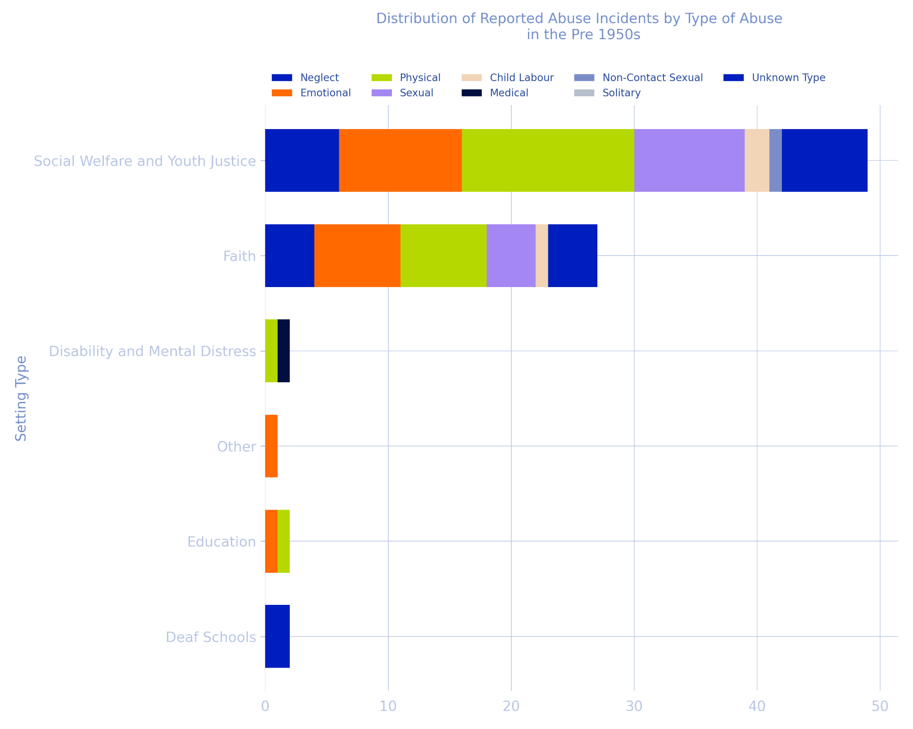

Decade of Abuse | Setting Type | Abuse Type | Incident Count | Proportion of Total Incidents (Decade)
Pre 1950 | Social Welfare and Youth Justice | Neglect | 6 | 8%
 |  | Emotional | 10 | 13%
 |  | Physical | 14 | 19%
 |  | Sexual | 9 | 12%
 |  | Child Labour | 2 | 3%
 |  | Medical | 0 | 0%
 |  | Non-Contact Sexual | 1 | 1%
 |  | Solitary | 0 | 0%
 |  | Unknown Type | 7 | 9%
 | Faith | Neglect | 4 | 5%
 |  | Emotional | 7 | 9%
 |  | Physical | 7 | 9%
 |  | Sexual | 4 | 5%
 |  | Child Labour | 1 | 1%
 |  | Medical | 0 | 0%
 |  | Non-Contact Sexual | 0 | 0%
 |  | Solitary | 0 | 0%
 |  | Unknown Type | 4 | 5%
 | Disability and Mental Distress | Neglect | 0 | 0%
 |  | Emotional | 0 | 0%
 |  | Physical | 1 | 1%
 |  | Child Labour | 0 | 0%
 |  | Physical | 0 | 0%
 |  | Medical | 1 | 1%
 |  | Non-Contact Sexual | 0 | 0%
 |  | Solitary | 0 | 0%
 |  | Unknown Type | 0 | 0%
 | Other | Neglect | 0 | 0%
 |  | Emotional | 1 | 1%
 |  | Physical | 0 | 0%
 |  | Sexual | 0 | 0%
 |  | Child Labour | 0 | 0%
 |  | Medical | 0 | 0%
 |  | Non-Contact Sexual | 0 | 0%
 |  | Solitary | 0 | 0%
 |  | Unknown Type | 0 | 0%
 | Education | Neglect | 0 | 0%
 |  | Emotional | 1 | 1%
 |  | Physical | 1 | 1%
 |  | Sexual | 0 | 0%
 |  | Child Labour | 0 | 0%
 |  | Medical | 0 | 0%
 |  | Non-Contact Sexual | 0 | 0%
 |  | Solitary | 0 | 0%
 |  | Unknown Type | 0 | 0%
 | Deaf Schools | Neglect | 0 | 0%
 |  | Emotional | 0 | 0%
 |  | Physical | 0 | 0%
 |  | Sexual | 0 | 0%
 |  | Child Labour | 0 | 0%
 |  | Medical | 0 | 0%
 |  | Non-Contact Sexual | 0 | 0%
 |  | Solitary | 0 | 0%
 |  | Unknown Type | 2 | 3%
 |  | Total Incident Count (Decade) | 75

1950s
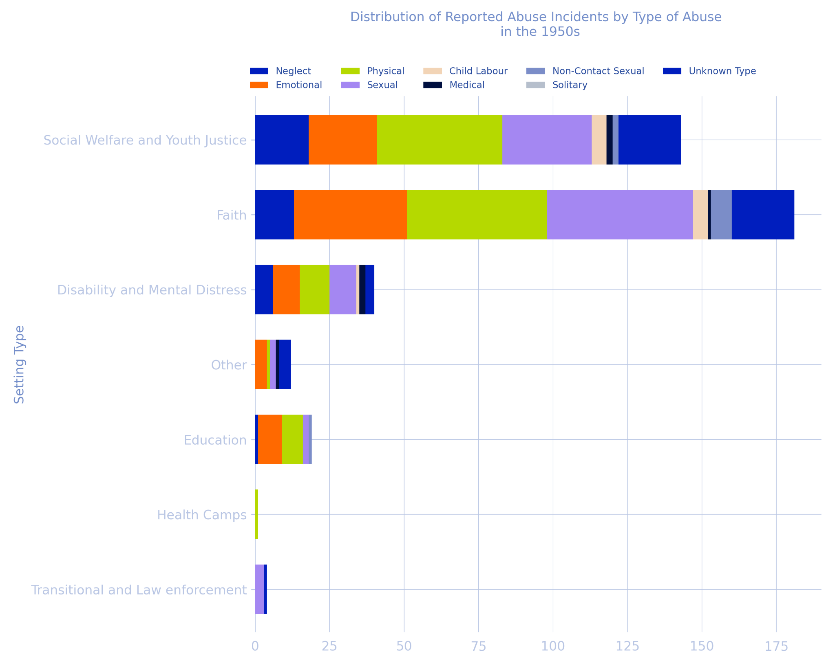

Decade of Abuse | Setting Type | Abuse Type | Incident Count | Proportion of Total Incidents (Decade)
1950s | Social Welfare and Youth Justice | Neglect | 18 | 5%
 |  | Emotional | 23 | 7%
 |  | Physical | 42 | 12%
 |  | Sexual | 30 | 9%
 |  | Child Labour | 5 | 1%
 |  | Medical | 2 | 1%
 |  | Non-Contact Sexual | 2 | 1%
 |  | Solitary | 0 | 0%
 |  | Unknown Type | 21 | 6%
 | Faith | Neglect | 13 | 4%
 |  | Emotional | 38 | 11%
 |  | Physical | 47 | 14%
 |  | Sexual | 49 | 15%
 |  | Child Labour | 5 | 1%
 |  | Medical | 1 | 0.3%
 |  | Non-Contact Sexual | 7 | 2%
 |  | Solitary | 0 | 0%
 |  | Unknown Type | 21 | 6%
 | Disability and Mental Distress | Neglect | 6 | 2%
 |  | Emotional | 9 | 3%
 |  | Physical | 10 | 3%
 |  | Sexual | 9 | 3%
 |  | Child Labour | 1 | 0.3%
 |  | Medical | 2 | 1%
 |  | Non-Contact Sexual | 0 | 0%
 |  | Solitary | 0 | 0%
 |  | Unknown Type | 3 | 1%
 | Other | Neglect | 0 | 0%
 |  | Emotional | 4 | 1%
 |  | Physical | 1 | 0.3%
 |  | Sexual | 2 | 1%
 |  | Child Labour | 0 | 0%
 |  | Medical | 1 | 0.3%
 |  | Non-Contact Sexual | 0 | 0%
 |  | Solitary | 0 | 0%
 |  | Unknown Type | 4 | 1%
 | Education | Neglect | 1 | 0%
 |  | Emotional | 8 | 2%
 |  | Physical | 7 | 2%
 |  | Sexual | 2 | 1%
 |  | Child Labour | 0 | 0%
 |  | Medical | 0 | 0%
 |  | Non-Contact Sexual | 1 | 0%
 |  | Solitary | 0 | 0%
 |  | Unknown Type | 0 | 0%
 | Transitional and Law enforcement | Neglect | 0 | 0%
 |  | Emotional | 0 | 0%
 |  | Physical | 0 | 0%
 |  | Sexual | 3 | 1%
 |  | Child Labour | 0 | 0%
 |  | Medical | 0 | 0%
 |  | Non-Contact Sexual | 0 | 0%
 |  | Solitary | 0 | 0%
 |  | Unknown Type | 1 | 0.3%
 | Health Camps | Neglect | 0 | 0%
 |  | Emotional | 0 | 0%
 |  | Physical | 1 | 0.3%
 |  | Child Labour | 0 | 0%
 |  | Medical | 0 | 0%
 |  | Non-Contact Sexual | 0 | 0%
 |  | Solitary | 0 | 0%
 |  | Unknown Type | 0 | 0%
 |  | Total Incident Count (Decade) | 337

1960s
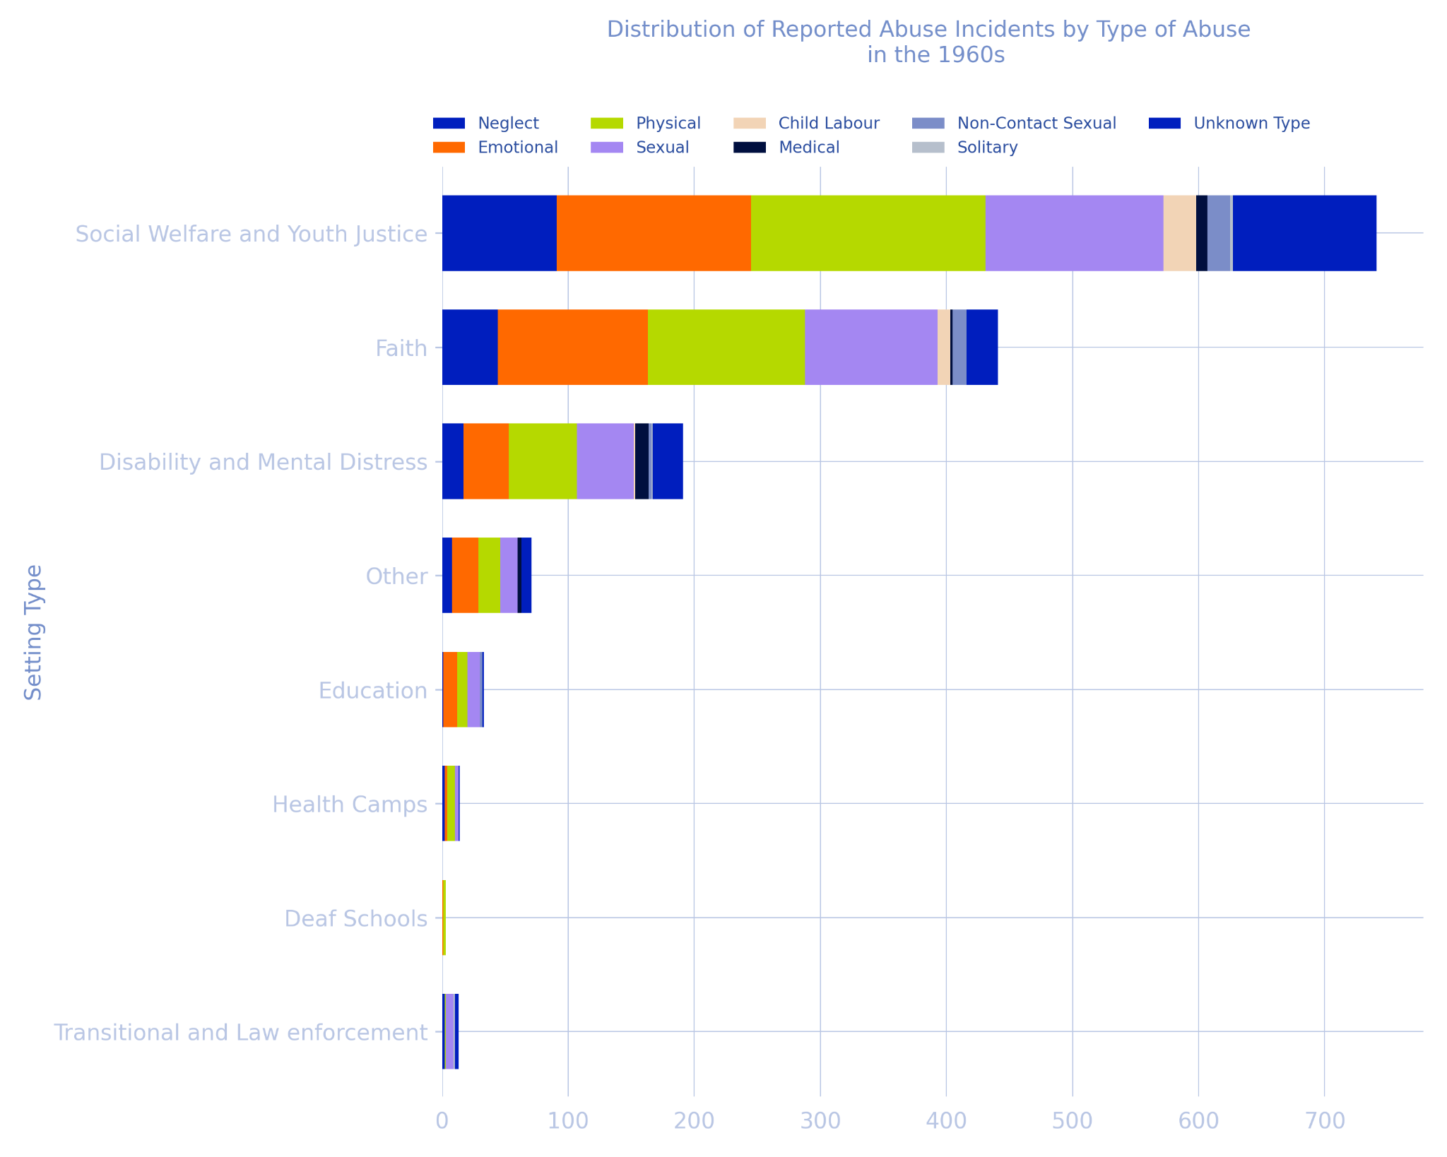
Decade of Abuse | Setting Type | Abuse Type | Incident Count | Proportion of Total Incidents (Decade)
1960s | Social Welfare and Youth Justice | Neglect | 91 | 8%
 |  | Emotional | 154 | 13%
 |  | Physical | 186 | 16%
 |  | Sexual | 141 | 12%
 |  | Child Labour | 26 | 2%
 |  | Medical | 9 | 1%
 |  | Non-Contact Sexual | 18 | 2%
 |  | Solitary | 2 | 0.2%
 |  | Unknown Type | 114 | 10%
 | Faith | Neglect | 44 | 4%
 |  | Emotional | 119 | 10%
 |  | Physical | 125 | 10%
 |  | Sexual | 105 | 9
 |  | Child Labour | 10 | 1%
 |  | Medical | 2 | 0.2%
 |  | Non-Contact Sexual | 11 | 1%
 |  | Solitary | 0 | 0%
 |  | Unknown Type | 25 | 2%
 | Disability and Mental Distress | Neglect | 17 | 1%
 |  | Emotional | 36 | 3%
 |  | Physical | 54 | 4%
 |  | Sexual | 45 | 4%
 |  | Child Labour | 1 | 0.1%
 |  | Medical | 11 | 1%
 |  | Non-Contact Sexual | 2 | 0.2%
 |  | Solitary | 1 | 0.1%
 |  | Unknown Type | 24 | 2%
 | Other | Neglect | 8 | 1%
 |  | Emotional | 21 | 2%
 |  | Physical | 17 | 1%
 |  | Sexual | 14 | 1%
 |  | Child Labour | 0 | 0%
 |  | Medical | 3 | 0.3%
 |  | Non-Contact Sexual | 0 | 0%
 |  | Solitary | 0 | 0%
 |  | Unknown Type | 8 | 1%
 | Education | Neglect | 1 | 0.1%
 |  | Emotional | 11 | 1%
 |  | Physical | 8 | 1%
 |  | Sexual | 10 | 1%
 |  | Child Labour | 0 | 0%
 |  | Medical | 0 | 0%
 |  | Non-Contact Sexual | 2 | 0.2%
 |  | Solitary | 0 | 0%
 |  | Unknown Type | 1 | 0.1%
 | Transitional and Law enforcement | Neglect | 2 | 0.2%
 |  | Emotional | 0 | 0%
 |  | Physical | 1 | 0.1%
 |  | Sexual | 6 | 0.5%
 |  | Child Labour | 0 | 0%
 |  | Medical | 0 | 0%
 |  | Non-Contact Sexual | 0 | 0%
 |  | Solitary | 1 | 0.1%
 |  | Unknown Type | 3 | 0.3%
 | Health Camps | Neglect | 2 | 0.2%
 |  | Emotional | 2 | 0.2%
 |  | Physical | 6 | 0.5%
 |  | Sexual | 3 | 0.3%
 |  | Child Labour | 0 | 0%
 |  | Medical | 0 | 0%
 |  | Non-Contact Sexual | 0 | 0%
 |  | Solitary | 0 | 0%
 |  | Unknown Type | 1 | 0.1%
 | Deaf Schools | Neglect | 0 | 0%
 |  | Emotional | 1 | 0.1%
 |  | Physical | 2 | 0.2%
 |  | Sexual | 0 | 0%
 |  | Child Labour | 0 | 0%
 |  | Medical | 0 | 0%
 |  | Non-Contact Sexual | 0 | 0%
 |  | Solitary | 0 | 0%
 |  | Unknown Type | 0 | 0%
 | Blind Schools | Neglect | 0 | 0%
 |  | Emotional | 1 | 0.1%
 |  | Physical | 1 | 0.1%
 |  | Sexual | 0 | 0%
 |  | Child Labour | 0 | 0%
 |  | Medical | 0 | 0%
 |  | Non-Contact Sexual | 0 | 0%
 |  | Solitary | 0 | 0%
 |  | Unknown Type | 0 | 0%
 |  | Total Incident Count (Decade) | 1200

1970s
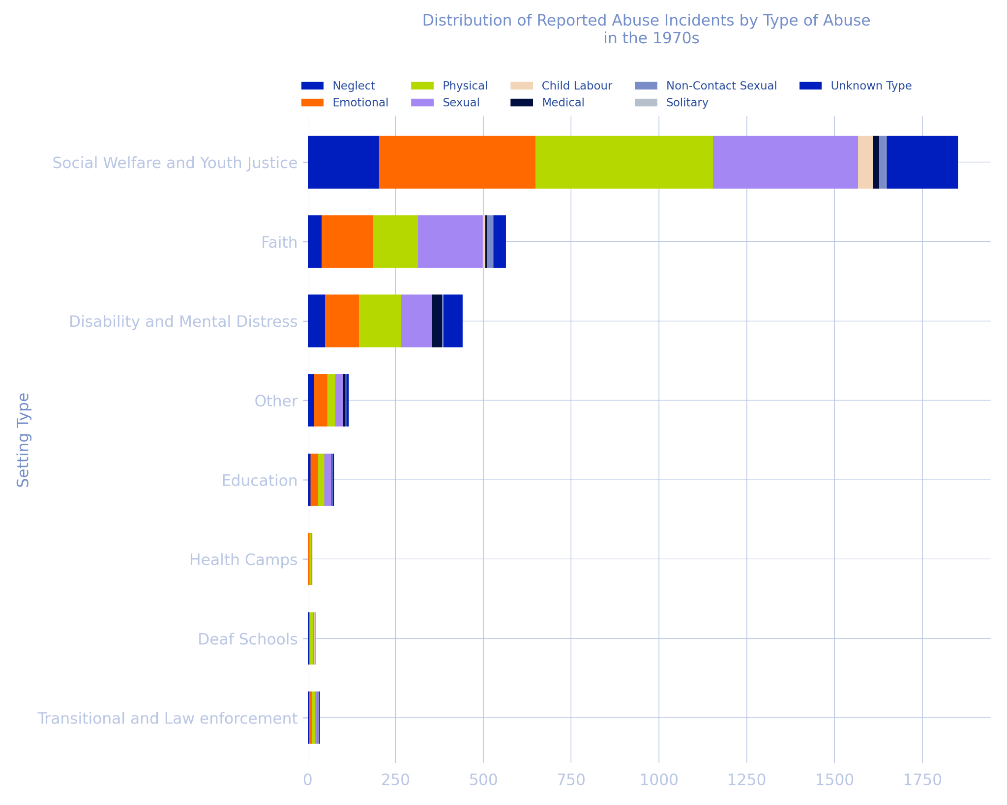
Decade of Abuse | Setting Type | Abuse Type | Incident Count | Proportion of Total Incidents (Decade)
1970s | Social Welfare and Youth Justice | Neglect | 203 | 8%
 |  | Emotional | 445 | 19%
 |  | Physical | 506 | 21%
 |  | Sexual | 413 | 17%
 |  | Child Labour | 43 | 2%
 |  | Medical | 17 | 1%
 |  | Non-Contact Sexual | 19 | 1%
 |  | Solitary | 2 | 0.1%
 |  | Unknown Type | 203 | 8%
 | Faith | Neglect | 40 | 2%
 |  | Emotional | 147 | 6%
 |  | Physical | 127 | 5%
 |  | Sexual | 184 | 8%
 |  | Child Labour | 8 | 0.3%
 |  | Medical | 4 | 0.2%
 |  | Non-Contact Sexual | 19 | 1%
 |  | Solitary | 0 | 0%
 |  | Unknown Type | 35 | 1%
 | Disability and Mental Distress | Neglect | 49 | 2%
 |  | Emotional | 97 | 4%
 |  | Physical | 120 | 5%
 |  | Sexual | 87 | 4%
 |  | Child Labour | 1 | 0%
 |  | Medical | 29 | 1%
 |  | Non-Contact Sexual | 3 | 0.1%
 |  | Solitary | 0 | 0%
 |  | Unknown Type | 55 | 2%
 | Other | Neglect | 19 | 1%
 |  | Emotional | 37 | 2%
 |  | Physical | 23 | 1%
 |  | Sexual | 21 | 1%
 |  | Child Labour | 1 | 0%
 |  | Medical | 6 | 0.3%
 |  | Non-Contact Sexual | 3 | 0.1%
 |  | Solitary | 0 | 0%
 |  | Unknown Type | 7 | 0.3%
 | Education | Neglect | 8 | 0.3%
 |  | Emotional | 22 | 1%
 |  | Physical | 17 | 1%
 |  | Sexual | 21 | 1%
 |  | Child Labour | 0 | 0%
 |  | Medical | 1 | 0%
 |  | Non-Contact Sexual | 2 | 0.1%
 |  | Solitary | 0 | 0%
 |  | Unknown Type | 4 | 0.2%
 | Transitional and Law enforcement | Neglect | 4 | 0.2%
 |  | Emotional | 8 | 0.3%
 |  | Physical | 9 | 0.4%
 |  | Sexual | 7 | 0.3%
 |  | Child Labour | 0 | 0%
 |  | Medical | 1 | 0%
 |  | Non-Contact Sexual | 1 | 0%
 |  | Solitary | 1 | 0%
 |  | Unknown Type | 4 | 0.2%
 | Health Camps | Neglect | 0 | 0%
 |  | Emotional | 5 | 0.2%
 |  | Physical | 5 | 0.2%
 |  | Child Labour | 1 | 0%
 |  | Medical | 0 | 0%
 |  | Non-Contact Sexual | 0 | 0%
 |  | Solitary | 0 | 0%
 |  | Unknown Type | 0 | 0%
 | Deaf Schools | Neglect | 3 | 0.1%
 |  | Emotional | 4 | 0.2%
 |  | Physical | 9 | 0.4%
 |  | Child Labour | 1 | 0%
 |  | Medical | 1 | 0%
 |  | Non-Contact Sexual | 1 | 0%
 |  | Solitary | 0 | 0%
 |  | Unknown Type | 0 | 0%
 |  | Total Incident Count (Decade) | 2390

1980s
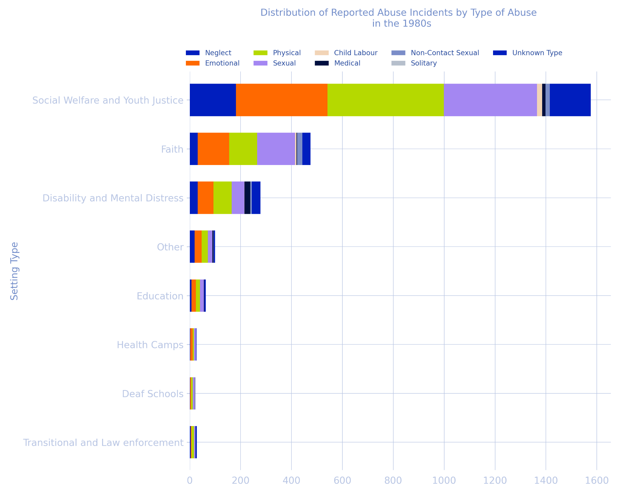

Decade of Abuse | Setting Type | Abuse Type | Incident Count | Proportion of Total Incidents (Decade)
1980s | Social Welfare and Youth Justice | Neglect | 182 | 10%
 |  | Emotional | 359 | 19%
 |  | Physical | 458 | 24%
 |  | Sexual | 366 | 19%
 |  | Child Labour | 20 | 1%
 |  | Medical | 13 | 1%
 |  | Non-Contact Sexual | 16 | 1%
 |  | Solitary | 1 | 0.1%
 |  | Unknown Type | 161 | 9%
 | Faith | Neglect | 31 | 2%
 |  | Emotional | 124 | 7%
 |  | Physical | 110 | 6%
 |  | Sexual | 149 | 8%
 |  | Child Labour | 5 | 0.3%
 |  | Medical | 3 | 0.2%
 |  | Non-Contact Sexual | 19 | 1%
 |  | Solitary | 1 | 0.1%
 |  | Unknown Type | 33 | 2%
 | Disability and Mental Distress | Neglect | 31 | 2%
 |  | Emotional | 62 | 3%
 |  | Physical | 72 | 4%
 |  | Sexual | 49 | 3%
 |  | Child Labour | 1 | 0.1%
 |  | Medical | 23 | 1%
 |  | Non-Contact Sexual | 4 | 0.2%
 |  | Solitary | 2 | 0.1%
 |  | Unknown Type | 34 | 2%
 | Other | Neglect | 19 | 1%
 |  | Emotional | 28 | 1%
 |  | Physical | 24 | 1%
 |  | Sexual | 18 | 1%
 |  | Child Labour | 0 | 0%
 |  | Medical | 4 | 0.2%
 |  | Non-Contact Sexual | 2 | 0.1%
 |  | Solitary | 0 | 0%
 |  | Unknown Type | 5 | 0.3%
 | Education | Neglect | 7 | 0.4%
 |  | Emotional | 17 | 1%
 |  | Physical | 16 | 1%
 |  | Sexual | 16 | 1%
 |  | Child Labour | 0 | 0%
 |  | Medical | 1 | 0.1%
 |  | Non-Contact Sexual | 0 | 0%
 |  | Solitary | 0 | 0%
 |  | Unknown Type | 6 | 0.3%
 | Transitional and Law enforcement | Neglect | 4 | 0.2%
 |  | Emotional | 3 | 0.2%
 |  | Physical | 10 | 1%
 |  | Sexual | 5 | 0.3
 |  | Child Labour | 0 | 0%
 |  | Medical | 1 | 0.1%
 |  | Non-Contact Sexual | 0 | 0%
 |  | Solitary | 0 | 0%
 |  | Unknown Type | 5 | 0.3%
 | Health Camps | Neglect | 2 | 0.1%
 |  | Emotional | 10 | 1%
 |  | Physical | 5 | 0.3%
 |  | Sexual | 7 | 0.4%
 |  | Child Labour | 0 | 0%
 |  | Medical | 0 | 0%
 |  | Non-Contact Sexual | 0 | 0%
 |  | Solitary | 0 | 0%
 |  | Unknown Type | 2 | 0.1%
 | Deaf Schools | Neglect | 1 | 0.1%
 |  | Emotional | 4 | 0.2%
 |  | Physical | 7 | 0.4%
 |  | Sexual | 7 | 0.4%
 |  | Child Labour | 1 | 0.1%
 |  | Medical | 1 | 0.1%
 |  | Non-Contact Sexual | 1 | 0.1%
 |  | Solitary | 0 | 0%
 |  | Unknown Type | 0 | 0%
 | Blind Schools | Neglect | 1 | 0.1%
 |  | Emotional | 0 | 0%
 |  | Physical | 0 | 0%
 |  | Sexual | 0 | 0%
 |  | Child Labour | 0 | 0%
 |  | Medical | 0 | 0%
 |  | Non-Contact Sexual | 0 | 0%
 |  | Solitary | 0 | 0%
 |  | Unknown Type | 0 | 0%
 |  | Total Incident Count (Decade) | 1881

1990s
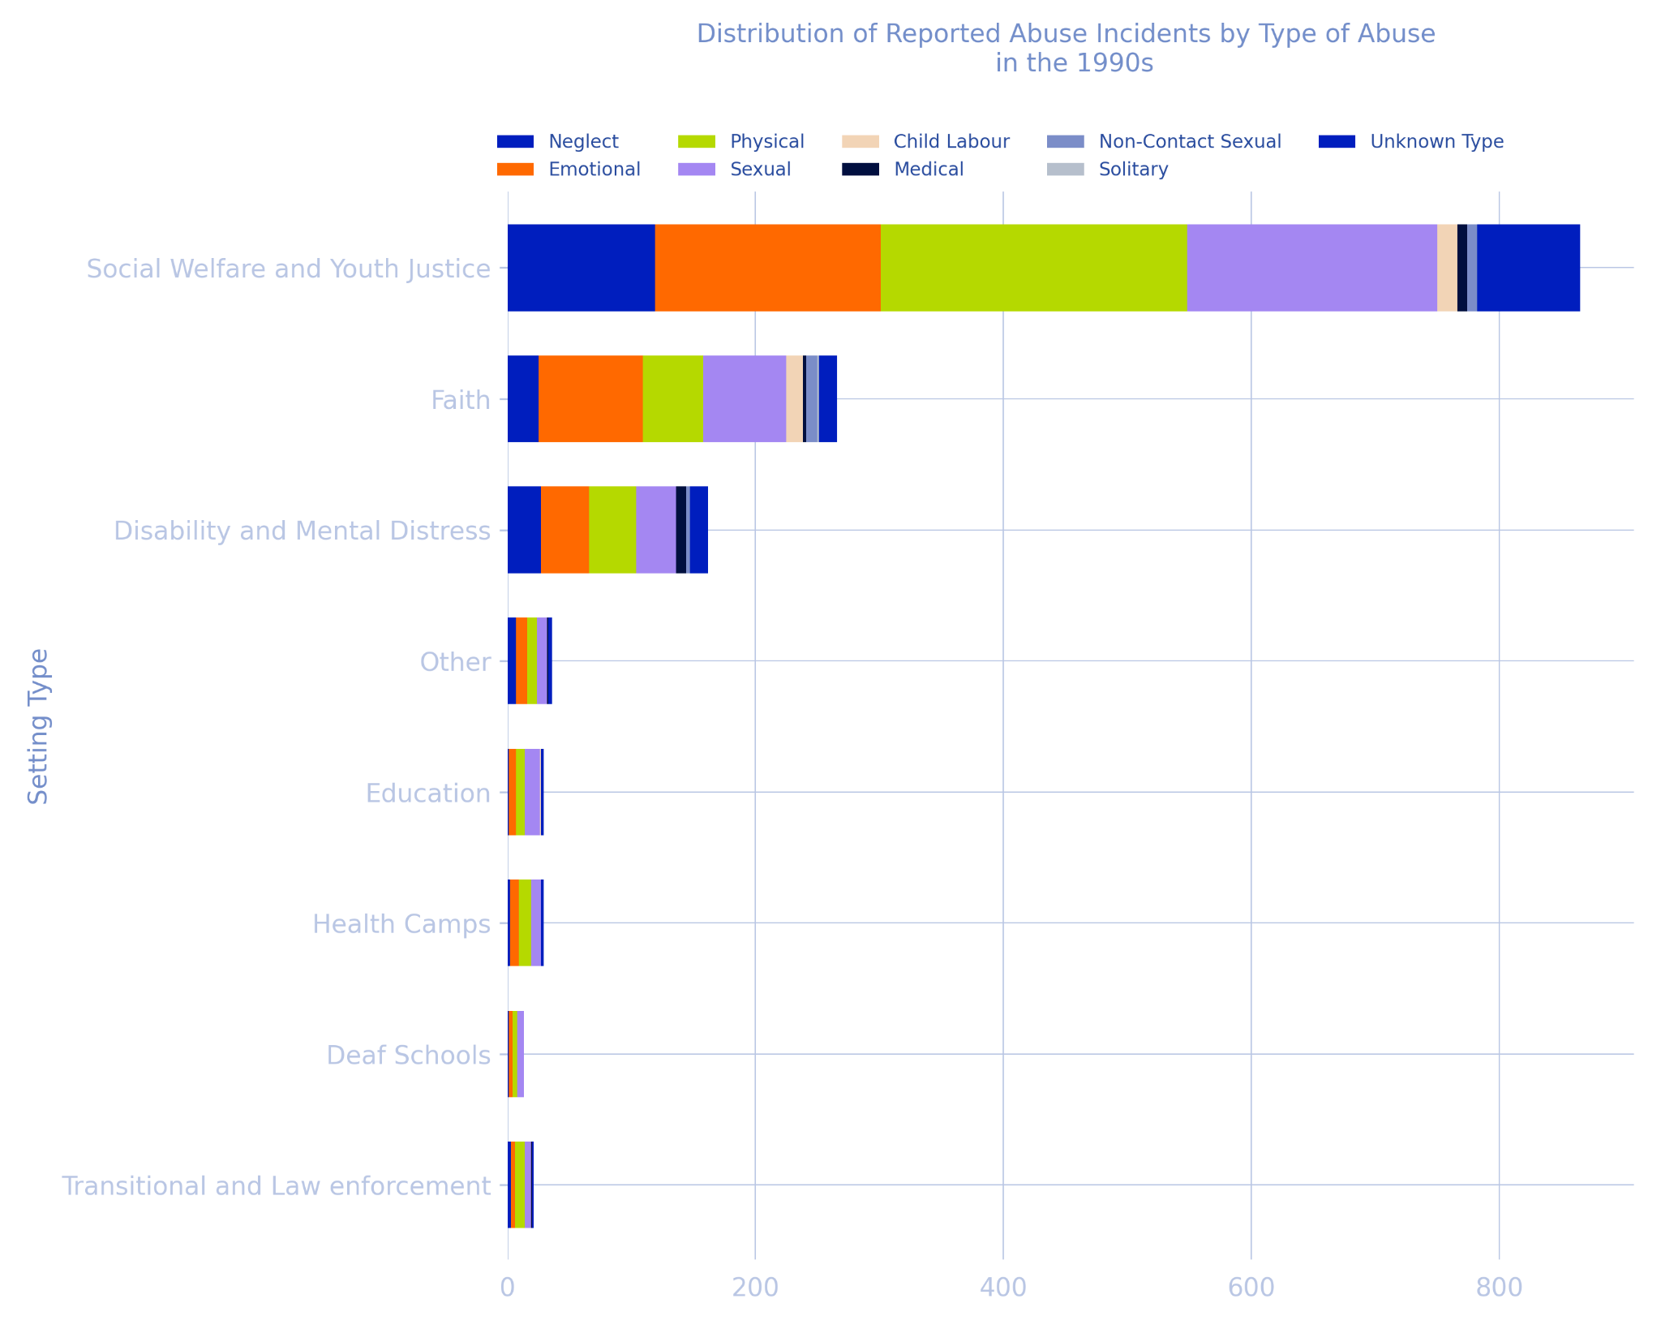
Decade of Abuse | Setting Type | Abuse Type | Incident Count | Proportion of Total Incidents (Decade)
1990s | Social Welfare and Youth Justice | Neglect | 119 | 12%
 |  | Emotional | 182 | 18%
 |  | Physical | 247 | 24%
 |  | Sexual | 202 | 20%
 |  | Child Labour | 16 | 2%
 |  | Medical | 8 | 1%
 |  | Non-Contact Sexual | 8 | 1%
 |  | Solitary | 0 | 0%
 |  | Unknown Type | 83 | 8%
 | Faith | Neglect | 25 | 2%
 |  | Emotional | 84 | 8%
 |  | Physical | 49 | 5%
 |  | Sexual | 67 | 7%
 |  | Child Labour | 13 | 1%
 |  | Medical | 3 | 0.3%
 |  | Non-Contact Sexual | 9 | 1%
 |  | Solitary | 1 | 0.1%
 |  | Unknown Type | 15 | 1%
 | Disability and Mental Distress | Neglect | 27 | 3%
 |  | Emotional | 39 | 4%
 |  | Physical | 38 | 4%
 |  | Sexual | 32 | 3%
 |  | Child Labour | 0 | 0%
 |  | Medical | 8 | 1%
 |  | Non-Contact Sexual | 3 | 0.3%
 |  | Solitary | 0 | 0%
 |  | Unknown Type | 15 | 1%
 | Other | Neglect | 7 | 1%
 |  | Emotional | 9 | 1%
 |  | Physical | 8 | 1%
 |  | Sexual | 8 | 1%
 |  | Child Labour | 0 | 0%
 |  | Medical | 1 | 0.1%
 |  | Non-Contact Sexual | 0 | 0%
 |  | Solitary | 0 | 0%
 |  | Unknown Type | 3 | 0.3%
 | Education | Neglect | 1 | 0.1%
 |  | Emotional | 6 | 1%
 |  | Physical | 7 | 1%
 |  | Sexual | 12 | 1%
 |  | Child Labour | 1 | 0.1%
 |  | Medical | 0 | 0%
 |  | Non-Contact Sexual | 0 | 0%
 |  | Solitary | 0 | 0%
 |  | Unknown Type | 2 | 0.2%
 | Transitional and Law enforcement | Neglect | 3 | 0.3%
 |  | Emotional | 3 | 0.3%
 |  | Physical | 8 | 1%
 |  | Sexual | 5 | 0.5%
 |  | Child Labour | 0 | 0%
 |  | Medical | 1 | 0.1%
 |  | Non-Contact Sexual | 0 | 0%
 |  | Solitary | 0 | 0%
 | Health Camps | Neglect | 2 | 0.2%
 |  | Emotional | 7 | 1%
 |  | Physical | 10 | 1%
 |  | Sexual | 8 | 1%
 |  | Child Labour | 0 | 0%
 |  | Medical | 0 | 0%
 |  | Non-Contact Sexual | 0 | 0%
 |  | Solitary | 0 | 0%
 |  | Unknown Type | 2 | 0.2%
 | Deaf Schools | Neglect | 1 | 0.1%
 |  | Emotional | 3 | 0.3%
 |  | Physical | 4 | 0.4%
 |  | Sexual | 5 | 0.5%
 |  | Child Labour | 0 | 0%
 |  | Medical | 0 | 0%
 |  | Non-Contact Sexual | 0 | 0%
 |  | Solitary | 0 | 0%
 |  | Unknown Type | 0 | 0%
 |  | Total Incident Count (Decade) | 1017

Post 2000s

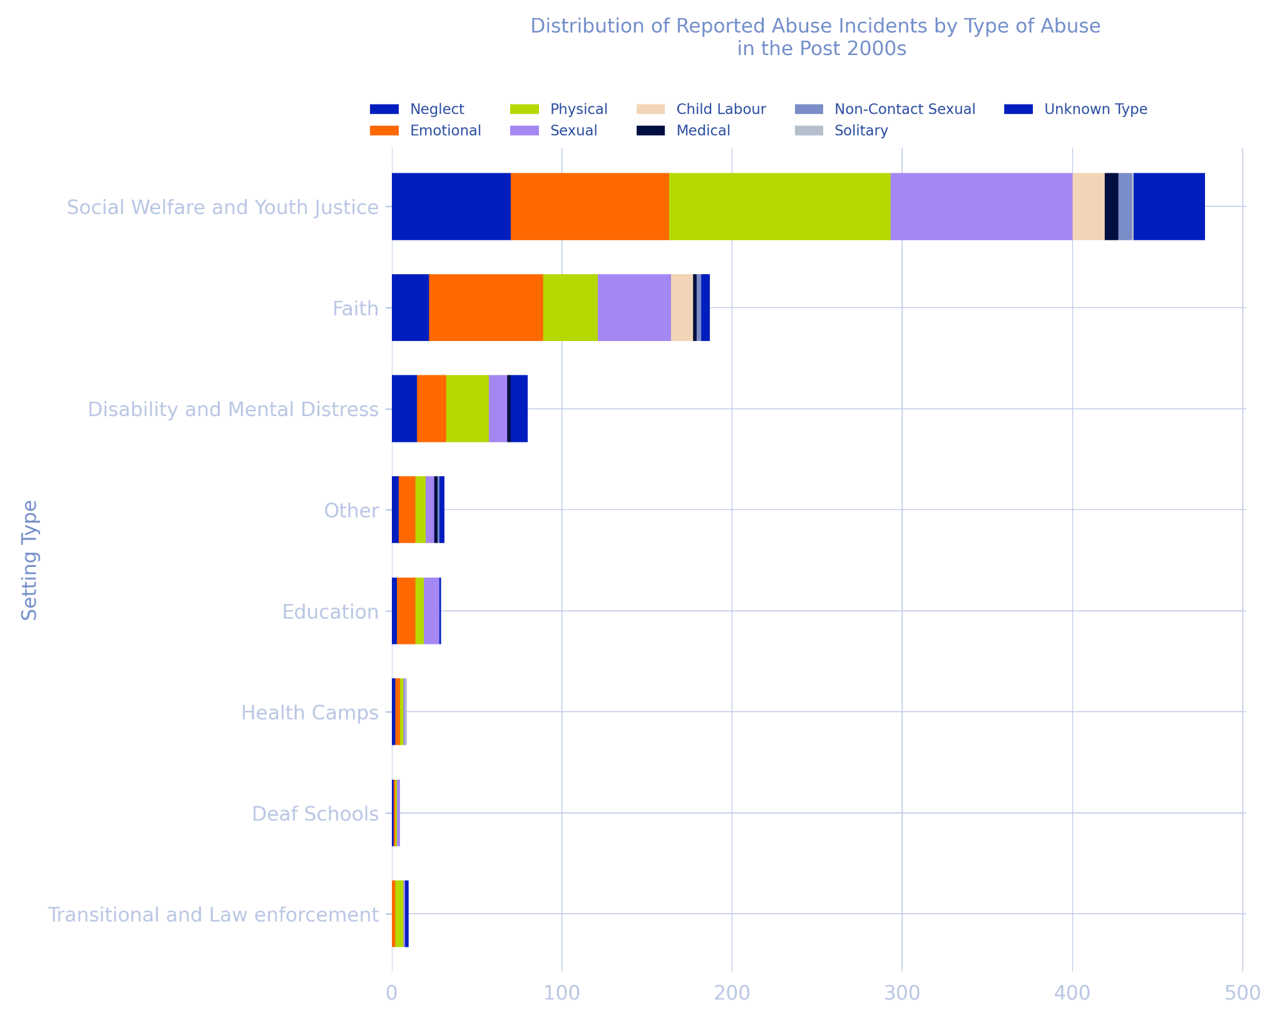
Decade of Abuse | Setting Type | Abuse Type | Incident Count | Proportion of Total Incidents (Decade)
>2000 | Social Welfare and Youth Justice | Neglect | 70 | 13%
 |  | Emotional | 93 | 18%
 |  | Physical | 130 | 25%
 |  | Sexual | 107 | 20%
 |  | Child Labour | 19 | 4%
 |  | Medical | 8 | 2%
 |  | Non-Contact Sexual | 8 | 2%
 |  | Solitary | 1 | 0.2%
 |  | Unknown Type | 42 | 8%
 | Faith | Neglect | 22 | 4%
 |  | Emotional | 67 | 13%
 |  | Physical | 32 | 6%
 |  | Sexual | 43 | 8%
 |  | Child Labour | 13 | 2%
 |  | Medical | 2 | 0.4%
 |  | Non-Contact Sexual | 3 | 1%
 |  | Solitary | 0 | 0%
 |  | Unknown Type | 5 | 1%
 | Disability and Mental Distress | Neglect | 15 | 3%
 |  | Emotional | 17 | 3%
 |  | Physical | 25 | 5%
 |  | Sexual | 11 | 2%
 |  | Child Labour | 0 | 0%
 |  | Medical | 2 | 0.4%
 |  | Non-Contact Sexual | 0 | 0%
 |  | Solitary | 0 | 0%
 |  | Unknown Type | 10 | 2%
 | Other | Neglect | 4 | 1%
 |  | Emotional | 10 | 2%
 |  | Physical | 6 | 1%
 |  | Sexual | 5 | 1%
 |  | Child Labour | 0 | 0%
 |  | Medical | 2 | 0.4%
 |  | Non-Contact Sexual | 1 | 0.2%
 |  | Solitary | 0 | 0%
 |  | Unknown Type | 3 | 1%
 | Education | Neglect | 3 | 1%
 |  | Emotional | 11 | 2%
 |  | Physical | 5 | 1%
 |  | Sexual | 9 | 2%
 |  | Child Labour | 0 | 0%
 |  | Medical | 0 | 0%
 |  | Non-Contact Sexual | 0 | 0%
 |  | Solitary | 0 | 0%
 |  | Unknown Type | 1 | 0.2%
 | Transitional and Law enforcement | Neglect | 0 | 0%
 |  | Emotional | 2 | 0.4%
 |  | Physical | 5 | 1%
 |  | Sexual | 1 | 0.2%
 |  | Child Labour | 0 | 0%
 |  | Medical | 0 | 0%
 |  | Non-Contact Sexual | 0 | 0%
 |  | Solitary | 0 | 0%
 |  | Unknown Type | 2 | 0.4%
 | Health Camps | Neglect | 2 | 0.4%
 |  | Emotional | 3 | 1%
 |  | Physical | 2 | 0.4%
 |  | Sexual | 1 | 0.2%
 |  | Child Labour | 0 | 0%
 |  | Medical | 0 | 0%
 |  | Non-Contact Sexual | 0 | 0%
 |  | Solitary | 1 | 0.2%
 |  | Unknown Type | 0 | 0%
 | Deaf Schools | Neglect | 1 | 0.2%
 |  | Emotional | 1 | 0.2%
 |  | Physical | 1 | 0.2%
 |  | Sexual | 2 | 0.4%
 |  | Child Labour | 0 | 0%
 |  | Medical | 0 | 0%
 |  | Non-Contact Sexual | 0 | 0%
 |  | Solitary | 0 | 0%
 |  | Unknown Type | 0 | 0%
 |  | Total Incident Count (Decade) | 525

- What is the ethnicity by decade
Decade of Abuse | Ethnicity | Incident Count | Percentage of Incidents
Pre 1950 | Pacific | 0 | 0%
 | Māori | 27 | 36%
 | Pakeha | 58 | 77%
 | Other | 9 | 12%
 | Total Incidents (Decade) | 75
1950s | Pacific | 1 | 0%
 | Māori | 60 | 18%
 | Pakeha | 299 | 89%
 | Other | 11 | 3%
 | Total Incidents (Decade) | 337
1960s | Pacific | 33 | 3%
 | Māori | 421 | 35%
 | Pakeha | 855 | 71%
 | Other | 62 | 5%
 | Total Incidents (Decade) | 1200
1970s | Pacific | 73 | 3%
 | Māori | 1209 | 51%
 | Pakeha | 1476 | 62%
 | Other | 83 | 3%
 | Total Incidents (Decade) | 2390
1980s | Pacific | 101 | 5%
 | Māori | 1002 | 53%
 | Pakeha | 1168 | 62%
 | Other | 49 | 3%
 | Total Incidents (Decade) | 1881
1990s | Pacific | 77 | 8%
 | Māori | 530 | 52%
 | Pakeha | 641 | 63%
 | Other | 36 | 4%
 | Total Incidents (Decade) | 1017
>2000 | Pacific | 29 | 6%
 | Māori | 256 | 49%
 | Pakeha | 305 | 58%
 | Other | 42 | 8%
 | Total Incidents (Decade) | 525

‘Other’ category in the table above relates to all the survivors who did not identify with Pacific, Māori, or Pakeha ethnicities.

For abuse incidents that occurred in a foster setting

What was the breakdown by decade of abuse incident
Setting | Decade of Abuse | Incident Count | Percentage of Abuse Incidents
Foster care, foster homes, family homes | Pre 1950 | 36 | 3%
 | 1950s | 71 | 6%
 | 1960s | 230 | 21%
 | 1970s | 466 | 42%
 | 1980s | 437 | 39%
 | 1990s | 276 | 25%
 | >2000 | 134 | 12%
 | Total Incidents (Foster Care) | 1108

What was the breakdown by type of abuse
Counting abusive incidents
Setting | Abuse Type | Incident Count | Percentage of Abuse Incidents
Foster care, foster homes, family homes | Neglect | 174 | 16%
 | Emotional | 284 | 26%
 | Physical | 386 | 35%
 | Sexual | 379 | 34%
 | Child Labour | 33 | 3%
 | Medical | 8 | 1%
 | Non-Contact Sexual | 23 | 2%
 | Solitary | 0 | 0%
 | Unknown Type | 120 | 11%
 | Total Incidents (Foster Care) | 1108

Counting survivors
Setting | Abuse Type | Number of Survivors | Percentage of Survivors
Foster care, foster homes, family homes | Neglect | 154 | 22%
 | Emotional | 249 | 35%
 | Physical | 331 | 46%
 | Sexual | 323 | 45%
 | Child Labour | 31 | 4%
 | Medical | 8 | 1%
 | Non-Contact Sexual | 21 | 3%
 | Solitary | 0 | 0%
 | Unknown Type | 110 | 15%
 | No Abuse Reported | 165 | 23%
 | Total Survivors in Care | 715

What was the breakdown of ethnicities that reported abuse in this setting
Counting abusive incidents
Setting | Ethnicity | Incident Count | Percentage of Abuse Incidents
Foster care, foster homes, family homes | Pacific | 57 | 5%
 | Māori | 615 | 56%
 | Pakeha | 666 | 60%
 | Other | 38 | 3%
 | Total Reported Incidents | 1108

Counting survivors
Setting | Ethnicity | Count of Survivors Reported Abuse | Percentage of Survivors
Foster care, foster homes, family homes | Pacific | 38 | 4%
 | Māori | 305 | 43%
 | Pakeha | 321 | 45%
 | Other | 21 | 3%
 | Total Survivors Reported Abuse | 550 | 77%
 | Total Survivors in Care | 715

For survivors who reported being deaf
- What was the setting breakdown of where this abuse occurred
Deaf
- What was the breakdown of the types of abuse reported

For survivors who were mobility impaired or had a physical disability
- What was the setting breakdown of where this abuse occurred
Disability - Mobility
- What was the breakdown of the types of abuse reported

For survivors who had a learning disability
- What was the setting breakdown of where this abuse occurred
Disability - Learning
- What was the breakdown of the types of abuse reported

For survivors who had a communication or speech impairment
- What was the setting breakdown of where this abuse occurred
Disability - Communication
- What was the breakdown of the types of abuse reported

For survivors who reported being neurodivergent
- What was the setting breakdown of where this abuse occurred
Neurodiversity
- What was the breakdown of the types of abuse reported

For survivors who were blind or had a vision impairment
- What was the setting breakdown of where this abuse occurred
Disability - Blind
- What was the breakdown of the types of abuse reported

