Royal Commission of Inquiry
into Abuse in Care

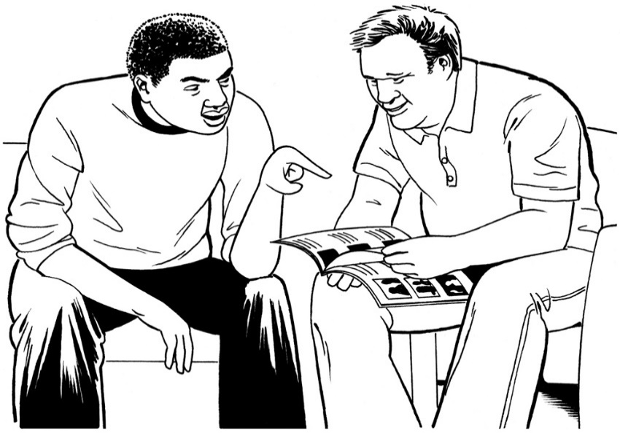

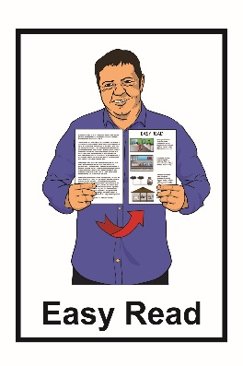
What the Royal Commission of Inquiry will do

November 2021
What is in this document?

Page number:
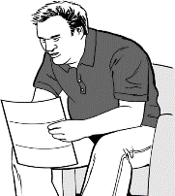

Before you read this.………...…..3

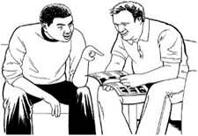
What is this document
about?.........................................5

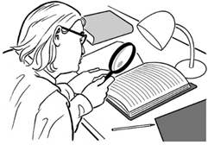
What will this investigation
look at?........................................9

What questions will the investigation be asking?............11

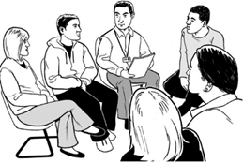
How will the investigation work?.........................................16

Page number:

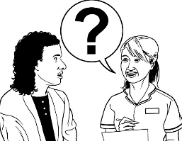
How people can share information with the investigation team..............18

What are the principles of the investigation?........………………….19

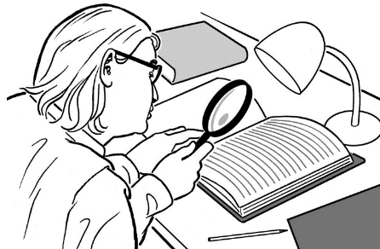
Who will be running this investigation?...................................22

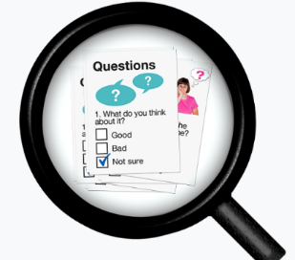
How will people know what the investigation team finds out?...........23

How to contact the Royal Commission…………………………29

Before you read this

This is a long document.

While it is written in Easy Read it can be hard for some people to read a document this long.

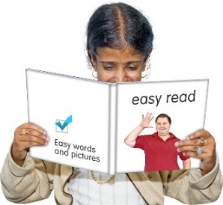
Some things you can do to make it easier are:

- read a few pages at a time
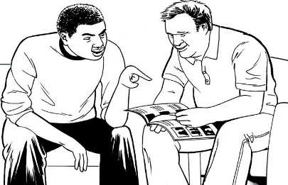

- have someone help you to understand it.

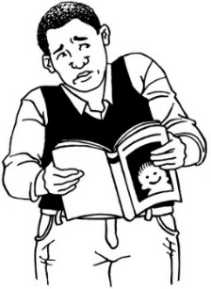
Some of the information in this document may make people upset when they are reading it.

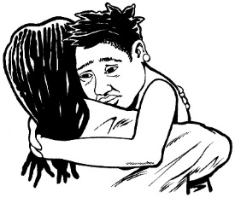
This information is:

- not meant to scare anyone

- not true for everyone with disability.

This information does not mean that these things will happen to you.

If you are worried after reading this document you can talk about it with your:

- family

- friends.

What is this document about?

This document is about the Royal Commission of Inquiry.

A Royal Commission of Inquiry is an investigation that looks at something that has already happened.

Doing an investigation means looking more closely at things that have happened in the past.
This investigation is about institutions.
Institutions are places where people lived in care.

The Government can ask the Royal Commission of Inquiry to do these investigations.

This investigation will look at how people were treated who lived in:

- state care institutions

- faith-based institutions.

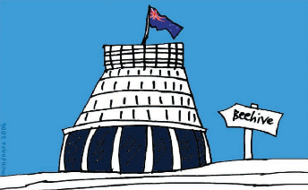
State care institutions are run by government agencies and are places that are meant to look after people.

Faith-based institutions are run by churches and are places that are meant to look after people.

The investigation will look into:
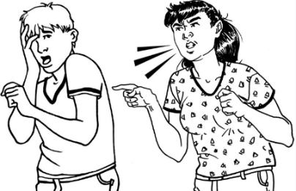
- abuse

- neglect.

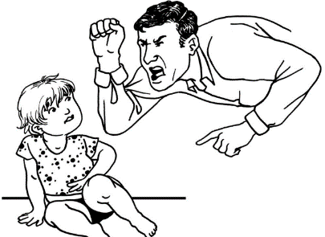
Abuse means when people who lived in these institutions were treated very badly.

Abuse can be:

- physical – a person kicking or hitting you
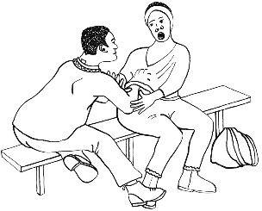
- sexual – when someone does sexual things to you that you do not want them to

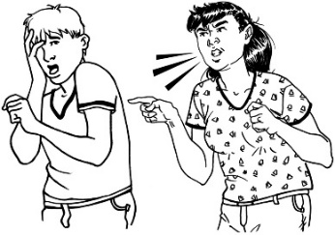
- emotional – yelling or saying things that are not nice to you.

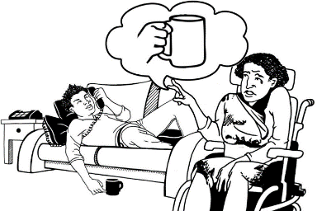
Neglect means when caregivers do not give a person all the things they need to feel well looked after.

This investigation is happening because lots of people have asked the Government to do it.

What will this investigation look at?

This investigation will look at how people were treated in institutions.

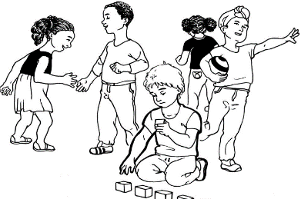
This means looking at what happened to:

- children
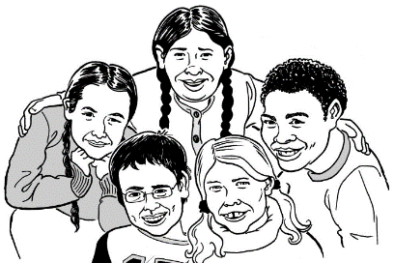
- young people

- vulnerable adults.

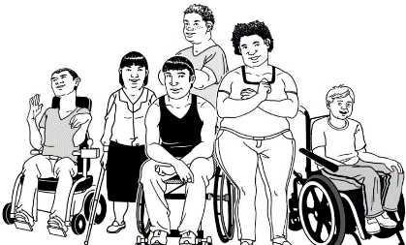
A vulnerable adult is a person who might need:
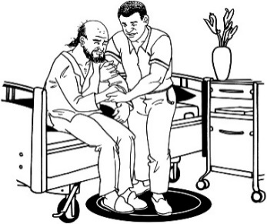
- more care than other people

- support to stay safe.

This investigation will look at what happened to people living in New Zealand institutions from 1950 to 1999.
1950
1999

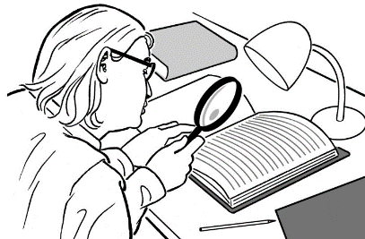
The investigation may also look at what happened to people who lived there:

- before 1950

- after 1999.

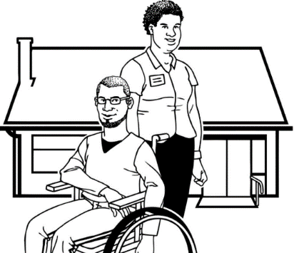
The investigation may also want to hear from people who live in care now.

What questions will the
investigation be asking?

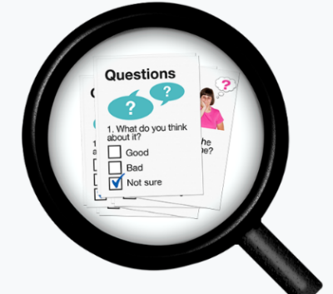
This Royal Commission of Inquiry investigation will be asking a lot of questions.

1 of the things the investigation team wants to know is:

Why were people put into institutions?
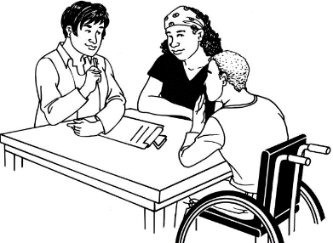

They want to know:

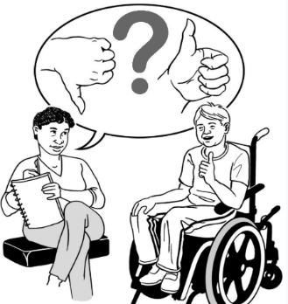
- how these choices were made

- if these choices were good choices.

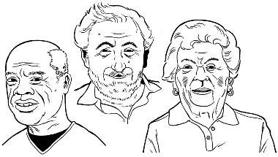
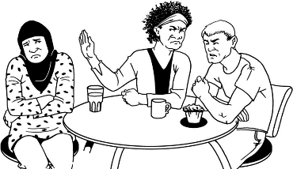
The Royal Commission of Inquiry also wants to know if these choices were made based on discrimination.
Discrimination means treating people in a different way because of things like their:

- age

- gender
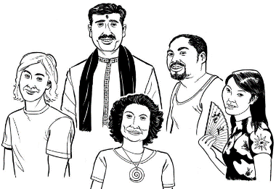
- disability

- culture.

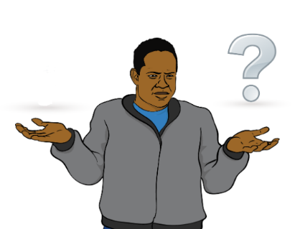
Another thing the investigation team wants to know is what happened to people when they lived in the institutions like:

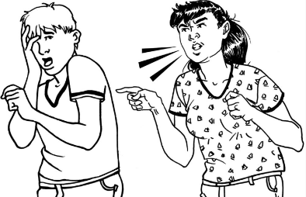
- how people were abused

- how people were neglected

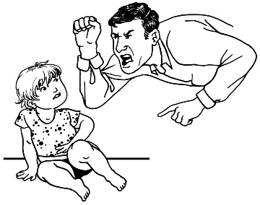
- where the abuse happened

- how many times the abuse happened
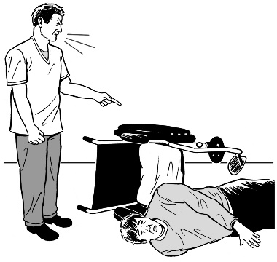
- why people were treated in this way
- how institutions let this abuse happen.
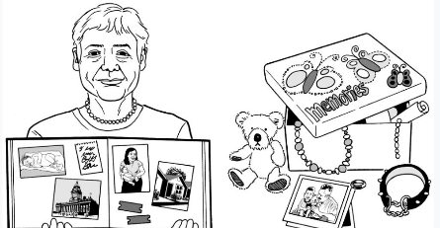
The investigation will also ask questions about how the abuse has affected:

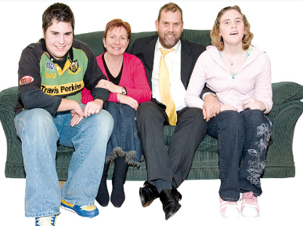
- people over their whole lives
- people’s family / whānau

          - other people in people’s lives.
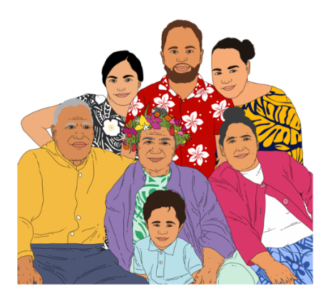
- future generations.

Future generations means people in your family who were born after you.

Another thing the investigation team wants to know is how things are working now.

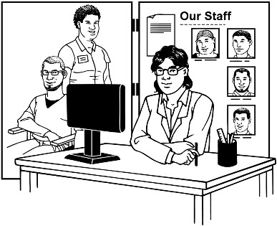
This means they are going to look into how services are:

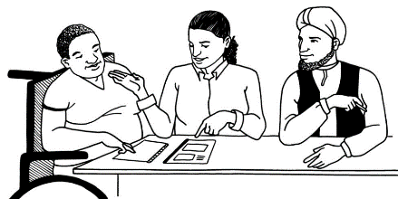
- trying to make life better for people who live in care

- supporting people to feel better.

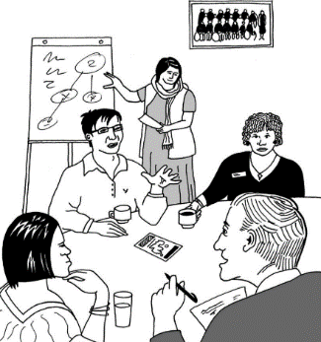
They also want to know how services can do things better in the future for people who live in care.
How will the investigation work?

The Royal Commission of Inquiry investigation team will get information by:

- listening to people
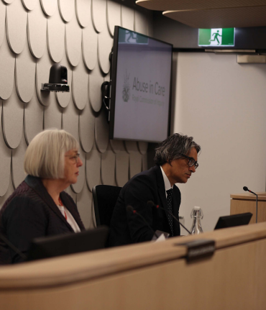
- having meetings called hearings.

Hearings are meetings that happen:
- in front of people from the Royal Commission

- in a place where anyone can come to the hearing
- in a way that is safe.

There will also be meetings called round table discussions.

Round table discussions are where people can get together to talk about something.

The investigation team will also get information from:

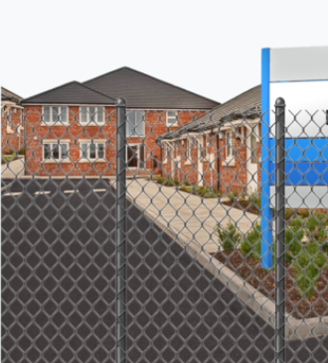
- reading information people send them

- looking at documents from the past.

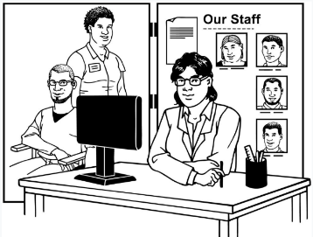
- institutions

- government agencies who run the places where people live in care
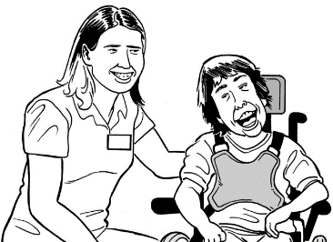
- people who work in the places where people live in care.
How people can share information
with the investigation team

People can also have their say by sending in their information.

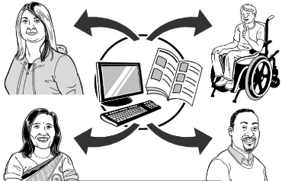
There are different ways people can share their information with the investigation team.

You can send in your information:

- by post
- by email.

What are the principles of the investigation?

The investigation team will follow some important principles.

Principles are rules that tell the Royal Commission how to treat people well.

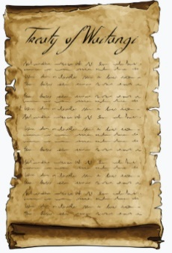
The investigation team will follow the ideas in Te Tiriti o Waitangi / Treaty of Waitangi.

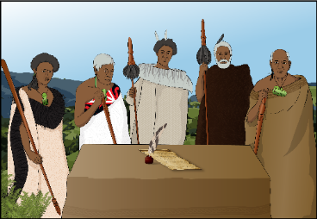
Te Tiriti o Waitangi / Treaty of Waitangi is an important agreement between Māori and the British Crown.

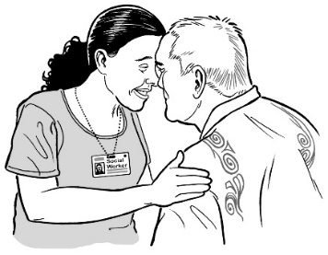
Following Te Tiriti o Waitangi means making sure that tāngata whenua / Māori are fully involved.

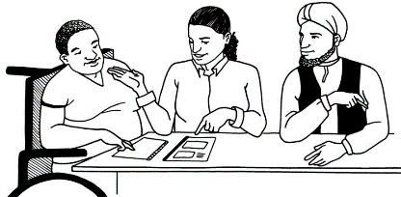
The investigation team also agrees to:

- work in a way that will not hurt people

- focus on the person who has been abused

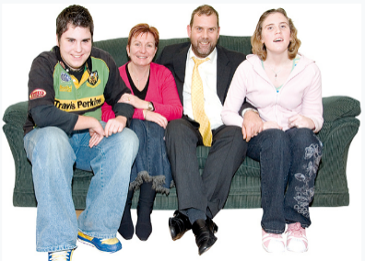
- work with people’s family / whānau

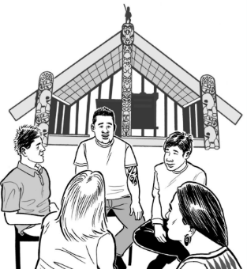
- work together with:

  - iwi

  - Māori
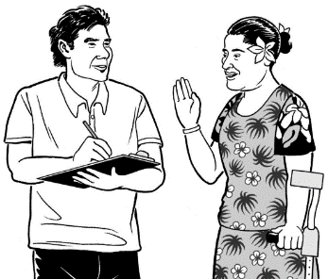
- work together with Pacific people

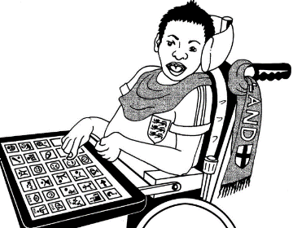
- make sure people with disabilities can have their say
- make sure people with mental health issues can have their say.

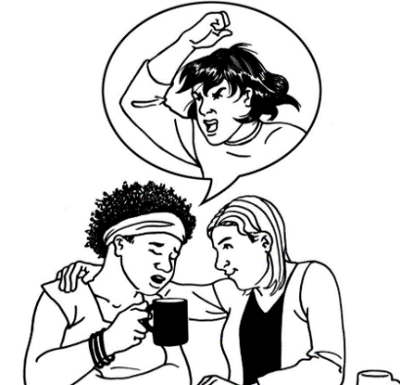
The investigation team knows that sharing this kind of information can be hard for people.

The investigation team will work hard to make sure:

- people feel safe sharing their information

- people feel like they have been able to have their say

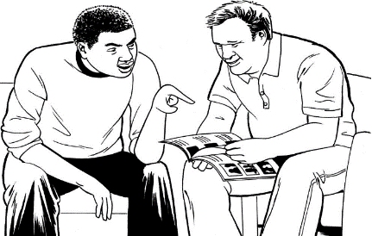
- the information is easy for everyone to understand.

Who will be running this investigation?

The Royal Commission of Inquiry will be running this investigation.

The Royal Commission of Inquiry is not part of:

- the Government
- faith-based institutions like churches.

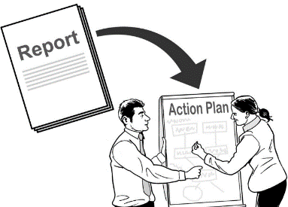
The inquiry will make recommendations to the Government when it has finished.

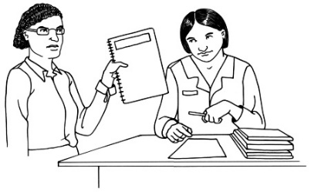
Recommendations are things that the Government should do to make things better for people.
How will people know what the
investigation team finds out?

The investigation team will write 3 reports.

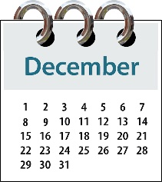
The first report was written in December 2020.

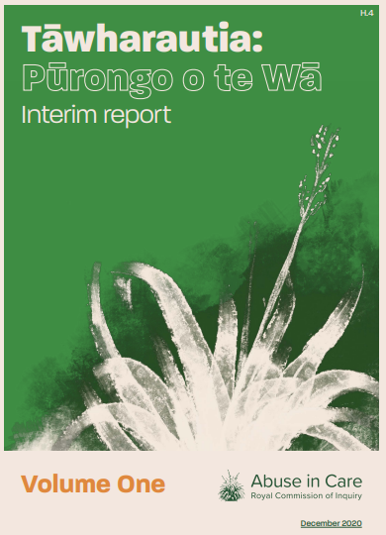
The first report was called:

Tāwharautia: Pūrongo o te Wā - Interim Report

You can find this first report in Easy Read on the Royal Commission website:

www.abuseincare.org.nz/library/v/194/tawharautia-purongo-o-te-wa-interim-report
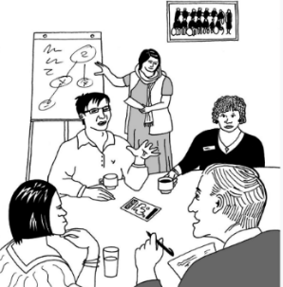
This report said things like:

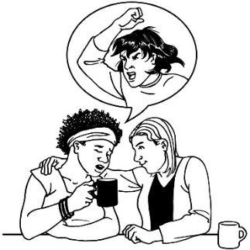
- what the investigation team found out

- what people said happened to them

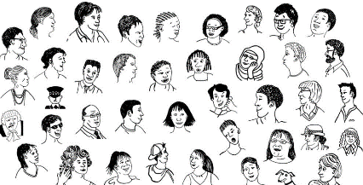
- how many people told the investigation team what happened to them

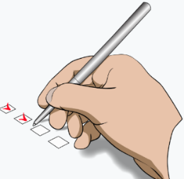
- what is needed now to make people’s lives better.

The second report will be written by December 2021.

This report will say what the investigation team thinks needs to be done for people who experienced abuse in:
- state care
- faith-based institutions.

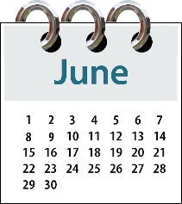
The third report will be written by June 2023.

This will be the final report.

This report will say things like:
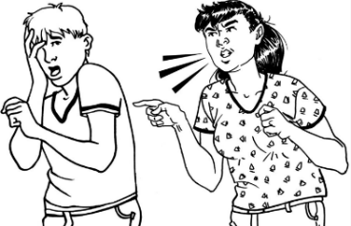
- what kind of abuse happened to people who lived in institutions
- how much the abuse happened

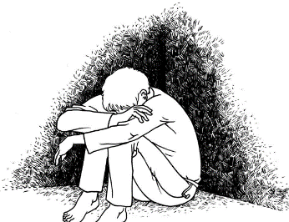
- how the abuse has made people feel

- how things are for people now
- what work still needs to be done.
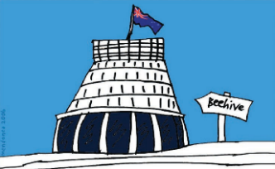
In this report the team will also make recommendations to:
- the New Zealand Government

- faith-based institutions.

The recommendations will say:

- how to stop more people from being abused
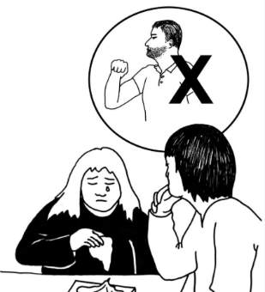
- what to do in the years to come if people are abused

- how to support people who have been abused.
- how to talk about how people have been hurt by abuse

- how to say sorry for what happened.
The Royal Commission of Inquiry has written this summary to help you understand more about this investigation.

A summary means the main information you might want to know.

A summary does not have all the information in it.

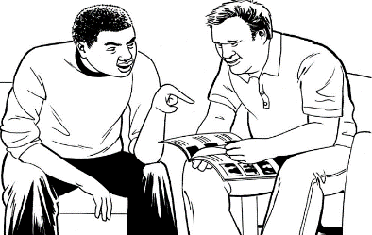
The full information is called the Terms of Reference.

You can find the Terms of Reference on the Royal Commission website:

https://www.abuseinstatecare.royalcommission.govt.nz/

How to contact the Royal Commission

If you have any questions you can contact the Royal Commission by.
Phone: 0800 222 727

Email:
contact@abuseincare.org.nz
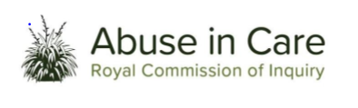
This information has been written by the Royal Commission of Inquiry into Abuse in Care.
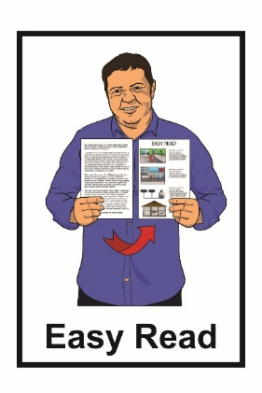
It has been translated into Easy Read by the Make It Easy service of People First New Zealand Inc. Ngā Tāngata Tuatahi.
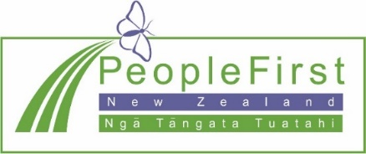
The ideas in this document are not the ideas of People First New Zealand Ngā Tāngata Tuatahi.
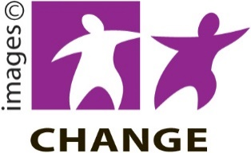
Make It Easy uses images from:
- Changepeople.org

- Photosymbols.com

- Sam Corliss

- Huriana Kopeke-Te Aho.

All images used in this Easy Read document are subject to copyright rules and cannot be used without permission.

